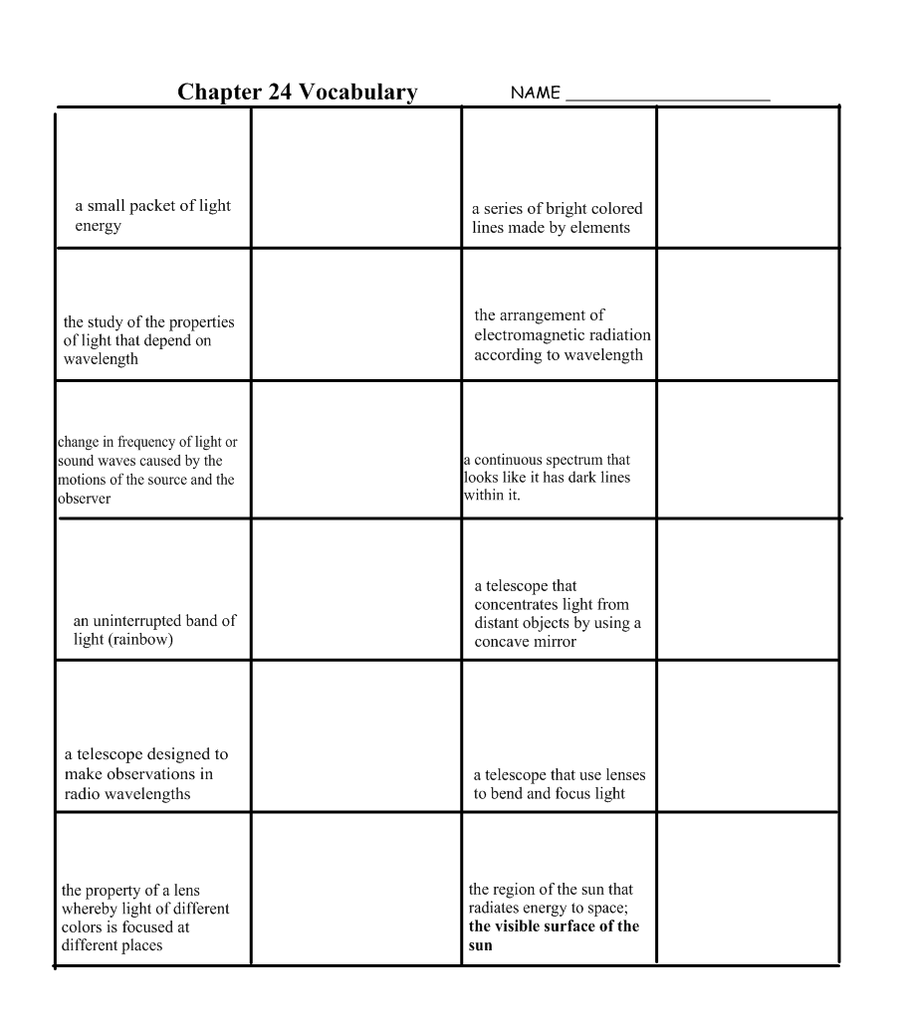

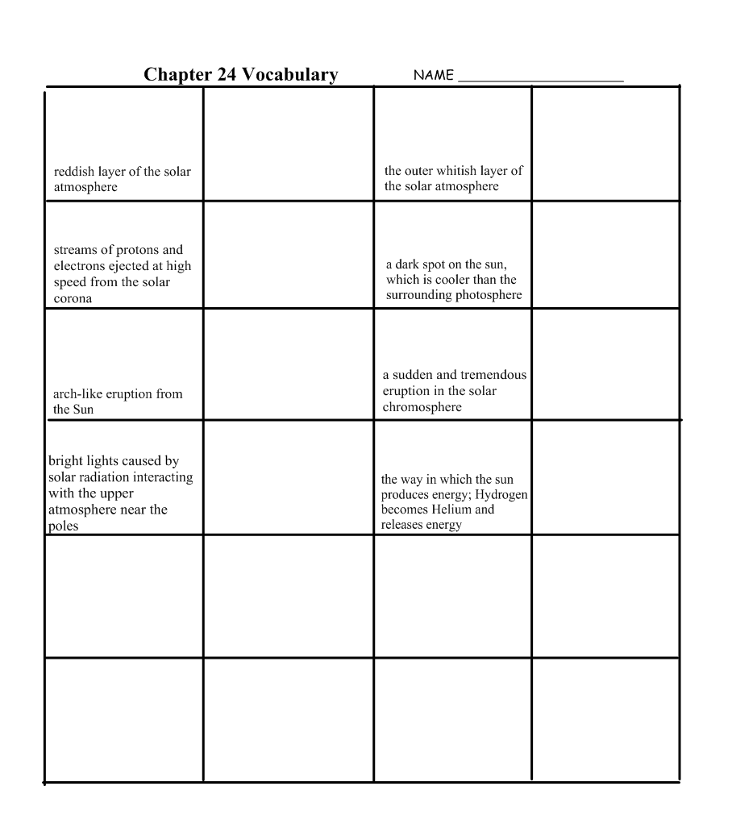

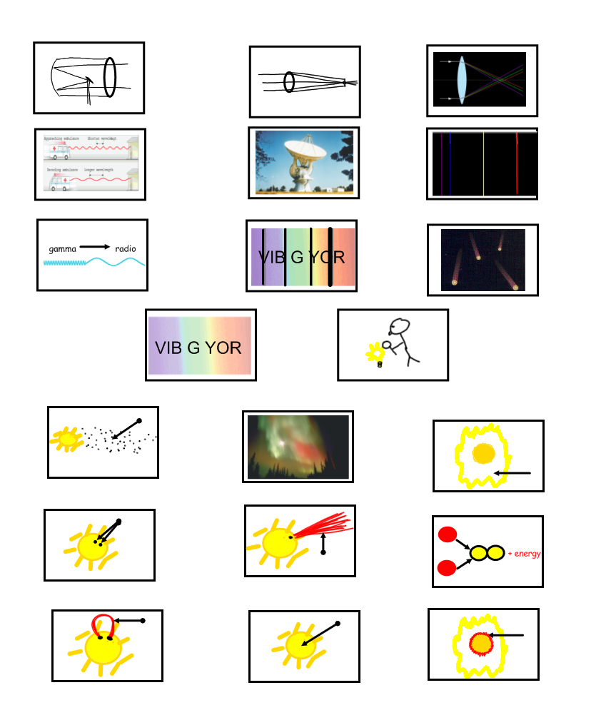
Refracting telescope
Reflecting telescope
Continuous spectrum
Spectroscopy
Radio telescope
Chromatic aberration
Doppler effect
Emission (bright-line) spectrum
Absorption (dark-line) spectrum
photon
Electromagnetic spectrum
Photosphere
Fusion (thermonuclear)
Solar wind
Solar flare
Corona
Aurora
Prominence
Chromosphere
sunspots

