Chapter 1 and Chemistry
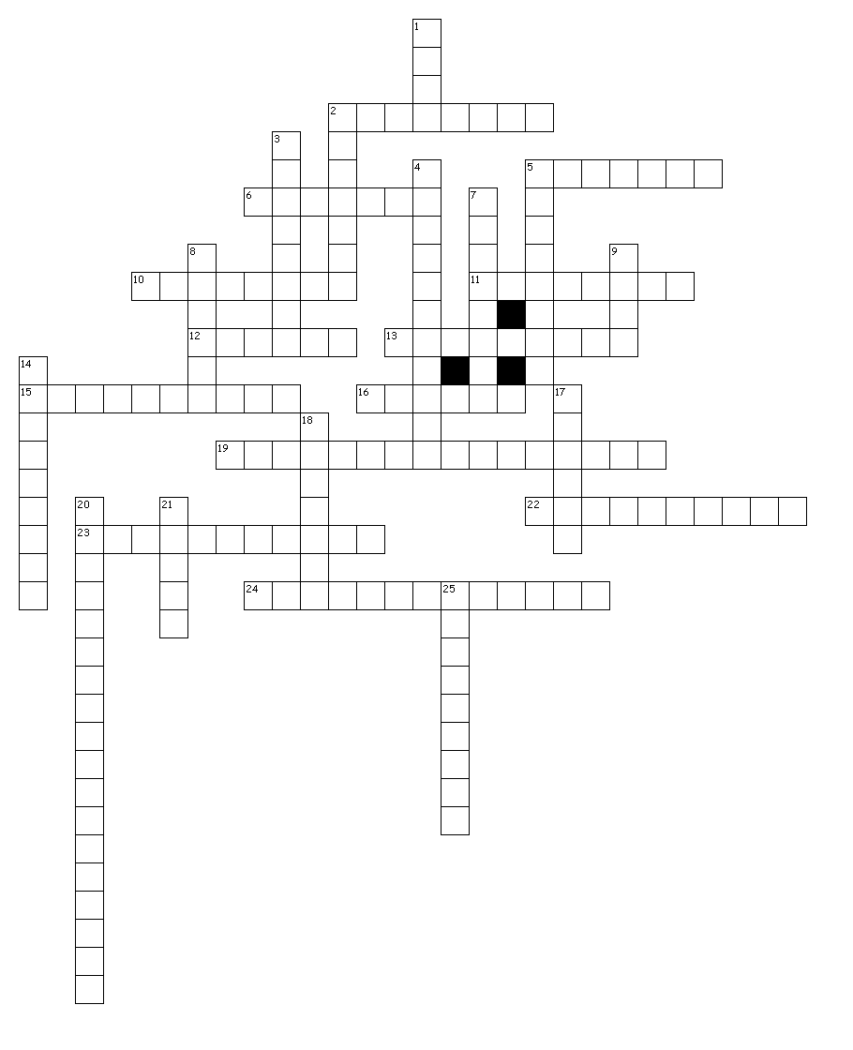

Across

2. An experiment should have one independent variable with as many other things as possible being ________________.
5. If a uranium atom undergoes alpha decay, it will become ____________________.
6. The particle in the atom with mass, but no charge.
10. Evaporation is an example of a __________________ change.
11. The two heat sources for the Earth system are the Sun and the _______________ of Earth.
12. An atom with 5 protons, 7 neutrons, and 8 electrons has a mass of _____________________.
13. If you believe that your friend looks mad today, you are making an:__________________
15. The most important part of the scientific method which sets it apart from philosophy is to _____________________.
16. 2000 mm = ___________ dl
19. The process by which one element turns into another and gives off energy and a particle from the nucleus.
22. A hypothesis must make a __________________ that can be tested.
23. If you notice that it is warm out, you have made an: ________________________
24. The line that should be drawn on a graph to show the trend of the data.

Down

1. The four fundamental measurements we make most often in science are length, time, temperature, and ______________________
2. The thing in an experiment that the independent variable is compared to.
3. The rusting of iron would be an example of a ___________________ change.
4. The variable in an experiment that is being tested.
5. An atom has a mass of 25 and an atomic number of 12, how many neutrons does it have? ____________________
7. Volume is considered an ________________________ measurement because it is calculated from length in three dimensions.
8. A group of interacting parts to make a more complex whole. _____________________________
9. An atom that has a mass of eleven, a charge of -3, and has eight electrons would have an atomic number of ________________.
14. The variable on a graph that should be on the y-axis.
17. A hypothesis may become a __________________only after it has been tested extensively and been supported by experiment.
18. 1 x 109 is a
20. the reason chemical formulas must be balanced is because they must obey the law of ___________________________________.
21. The metric base unit for length is the __________________.
25. Changing the number of ___________________ will change the charge of the atom, but not what it is or what it weighs.

