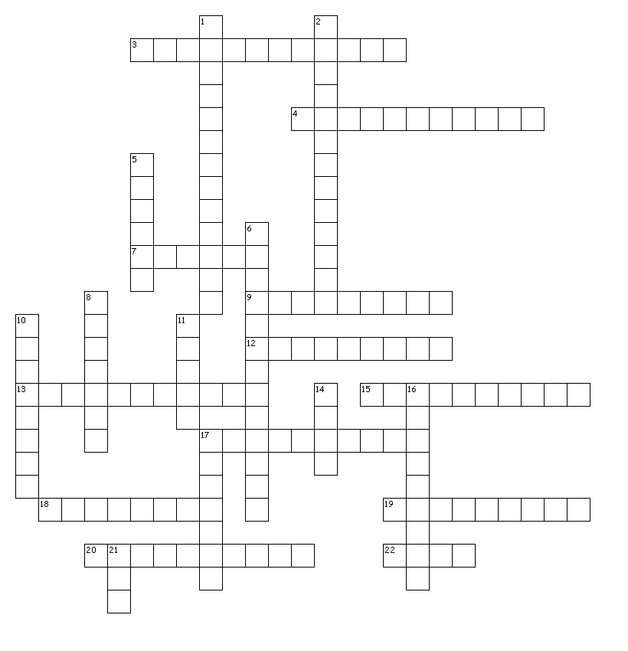
Chapter 4 Review

Across
3. Resources that are mined are almost always this type: __________________________
4. Coal, oil, and natural gas are this type of non-renewable resource: _______________________________
7. If our use of coal increases by 3.5% per year on average, how many years will it be until our coal consumption doubles? _____________________________
9. If it is grown, it is likely to be considered a _____________________________ resource.
12. In energy transformations, some energy is always lost which is why nothing can possibly be 100% _______________________________.
13. Renewable resources may not be ___________________ as population grows and demand for them rises.
15. Wind and solar power are both considered _____________________ which is why people off grid would need a battery or back-up generator with them.
17. This fossil fuel is the most efficient and causes the least pollution: ______________________
18. An apple has this type of energy.
19. All energy sources have _______________________ which is why no one energy source should be used to try and replace fossil fuels.
20. The biggest demand on our resources comes from growth in ___________________ and inefficient use of the resource.
22. The lost energy in energy transformations is often in the form of ______________ and sound.
Down
1. A person sitting on top of a table has this type of potential energy: _______________________
2. Alternative energy sources do not produce: _________________________________
5. One of the best advantages of solar and wind power especially, are that they can be used in ____________________ locations.
6. The problem with this alternative energy source is that there are few locations left to set it up. _________________________
8. Electricity falls under the category of _______________________ energy.
10. Type of rock found here in Colorado which contains kerogen and could help ease our dependence on conventional fossil fuels: ___________________________________________
11. This alternative energy source requires the least maintenance once it is set up: ___________________
14. This fossil fuel produces most of our electricity and it formed from land plants: ___________________
16. Things that we need and use are called:____________________________________
17. This type of alternative energy comes from Uranium which is not renewable: ____________________
21. A rock that contains a valuable resource that can be exreacted at a profit is considered an: _______

Resources Things that we need and use are called:____________________________________
Nonrenewable Resources that are mined are almost always this type: __________________________
Fossilfuels Coal, oil, and natural gas are this type of non-renewable resource: _______________________________
Oilshale Type of rock found here in Colorado which contains kerogen and could help ease our dependence on conventional fossil fuels: ___________________________________________
Ore A rock that contains a valuable resource that can be exreacted at a profit is considered an: _______
Renewable If it is grown, it is likely to be considered a ___________________ resource.
Sustainable Renewable resources may not be ___________________ as population grows and demand for them rises.
Chemical An apple has this type of energy.
Kinetic Electricity falls under the category of ___________________ energy.
Gravitational A person sitting on top of a table has this type of potential energy: _________________
Efficient In energy transformations, some energy is always lost which is why nothing can possibly be 100% __________________.
Carbondioxide Alternative energy sources do not produce: _________________________________
Drawbacks All energy sources have _______________________ which is why no one energy source should be used to try and replace fossil fuels.
Population The biggest demand on our resources comes from growth in ___________________ and inefficient use of the resource.
Unreliable Wind and solar power are both considered _____________________ which is why people off grid would need a battery or back-up generator with them.
Heat The lost energy in energy transformations is often in the form of ______________ and sound.
Twenty If our use of coal increases by 3.5% per year on average, how many years will it be until our coal consumption doubles? ____________________
Remote One of the best advantages of solar and wind power especially, are that they can be used in _____________ locations.
Nuclear This type of alternative energy comes from Uranium which is not renewable: _______________
Hydroelectric The problem with this alternative energy source is that there are few locations left to set it up. _________________________
Naturalgas This fossil fuel is the most efficient and causes the least pollution: ______________________
Coal This fossil fuel produces most of our electricity and it formed from land plants: _________________
Solar This alternative energy source requires the least maintenance once it is set up: ________________

