Interior Processes Study Guide NAME
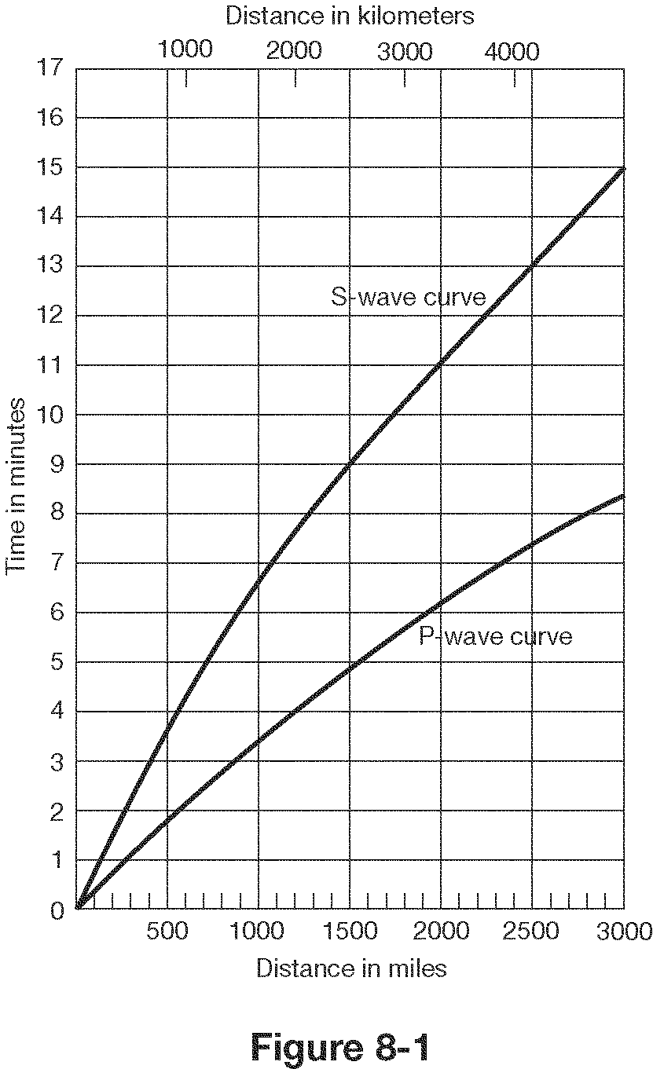

- How far does a P wave travel in 2 minutes? ________
- How far does an S wave travel in 4 minutes?__________
- How long does it take a P wave to travel 1500 miles?__________
- What is the lag time between P and S waves at 2000 km?__________
- What is the lag time for P and S waves at the epicenter?___________
- If there is a lag time of 4.5 minutes between P and S waves, how far is the epicenter?__________
- If there is a lag time of 2 minutes between P and S waves, how far is the epicenter?__________

Write P, S or Surface(L)
- Fastest waves-__________
- Slowest waves-__________
- Only travel through solids-__________
- Cause the most damage-__________
- Travel side to side-__________
- Push-Pull or compression waves-__________
- Can’t make it through the outer core-__________

15. The difference in the ____________________ of P waves and S waves is used to locate an earthquake’s epicenter.

16. The amount of damage that results from an earthquake depends on the intensity and duration of the earthquake, the nature of the material on which structures are built, and ____________________.

17. Can we predict earthquakes?

18. How do earthquakes provide evidence of plate tectonics?

19. List at least four dangers (factors affecting damage) that are associated with earthquakes.

20. How many seismic stations are needed to locate an earthquake?

21. What can we learn from earthquakes?

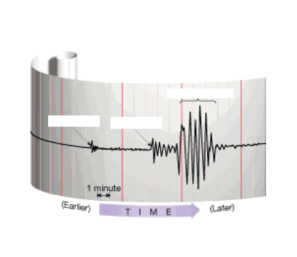
M.

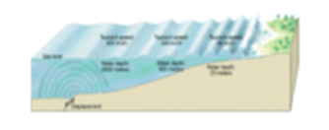
Match the following words with the correct definition and picture: Put both letters on the line.

N.
26. Seismogram - a. sudden release of energy as deformed rock snaps
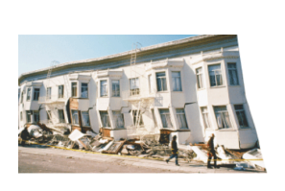
27.Lithosphere - b. solid layer of Earth under the crust

28. Epicenter - c. huge wave caused by an underwater earthquake
O.
29. Mantle - d. a recording of earthquake waves

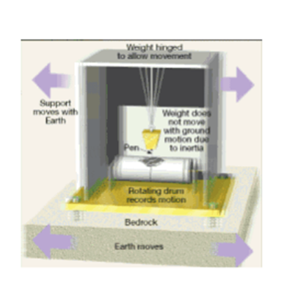
30. Asthenosphere - e. rigid layer of Earth made of crust and the uppermost mantle

31. Fault - f. solid innermost part of Earth, made of iron and nickel
P.
32. Focus - g. liquid layer of the Earth, made of iron and nickel

33. Outer core - h. surface location of an earthquake

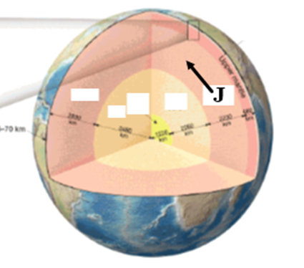
34. Seismograph - i. semi-molten layer of Earth in the upper mantle

35. Tsunami - j. crack in the Earth along which movement has occurred
Q.
36. Inner core - k. underground location of an earthquake, point of origin

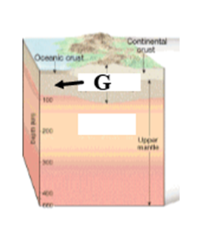
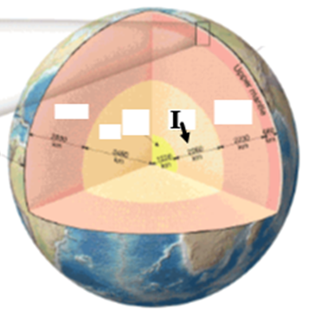
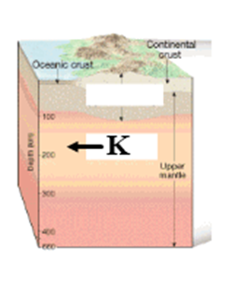
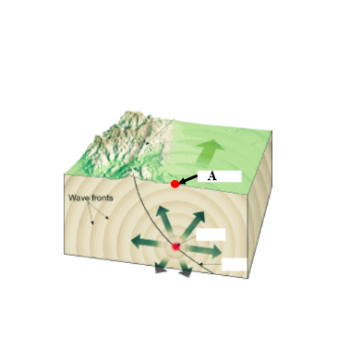
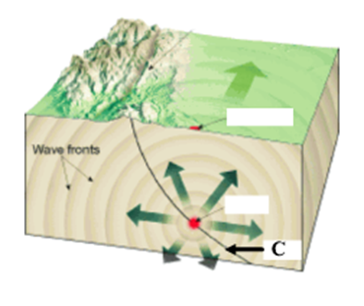
37. Earthquake - l. devise that measures and records earthquake waves
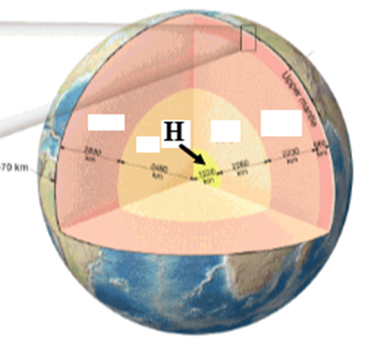
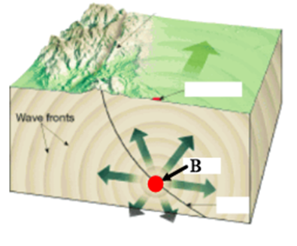

R. S. T. U. V. W. X.

38. What are the main pieces of evidence for plate tectonics?

39. Most earthquakes and volcanoes take place at ?
40. The Mid-Atlantic Ridge, where plates are moving apart, is an example of a boundary?
41. Crust is at diverging boundaries and at converging boundaries.
42. The Himalayas where two continental plates are colliding is an example of a boundary and the Andes Mountains where an ocean plate is being pushed under a continental plate is an example of a boundary, meaning the Andes mountains must be While the Himalayas are
43. Oceanic crust is always subducted under continental crust because it is
44. Hawaii is not located on a plate boundary, but it is the most volcanically active place in the world due to a
45. How do volcanoes provide evidence of plate tectonics?
46. What things influence the nature of a volcanic eruption?

What are some warning signs that a volcano may erupt?
47. Which volcano below will have an explosive eruption and why?
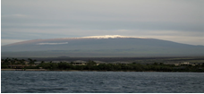
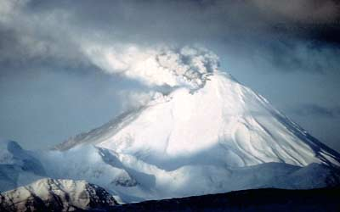

Identify the boundaries, on the second line, identify the geologic feature(s) found there

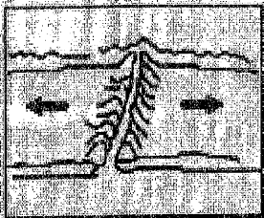
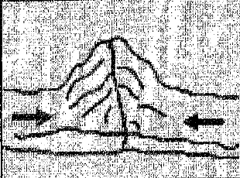
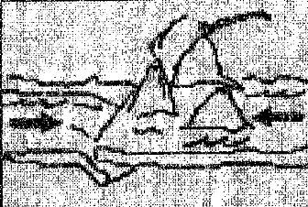
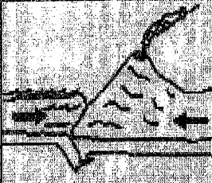

1. 2. 3. 4.
Diverging Collision Subduction (o&o) Subduction (o&c)

- Sea floor spreading is taking place at (above)

- Describe plate motions at:
    - Transform boundaries -
    - Converging boundaries -
    - Diverging boundaries -
- What was discovered near the center of the Atlantic Ocean?

- What discovery was made in bands of rock on either side of the Mid-Atlantic Ridge?

52. How do these bands support sea-floor spreading?
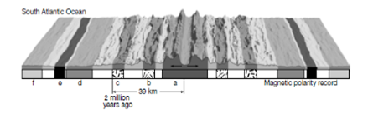

- Thickest sediments on sea floor

- Which two letters are the same age?

- Youngest rocks on sea floor
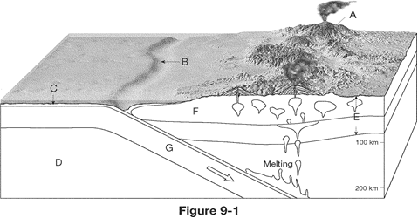
- What are some warning signs that a volcano may become active in the near future?

- What type of boundary is shown above?
- What are the two geologic structures found in the diagram above?

- Which crust is being subducted and why?

- What is the cause of the volcanoes in the diagram?

