Interior Processes Study Guide NAME
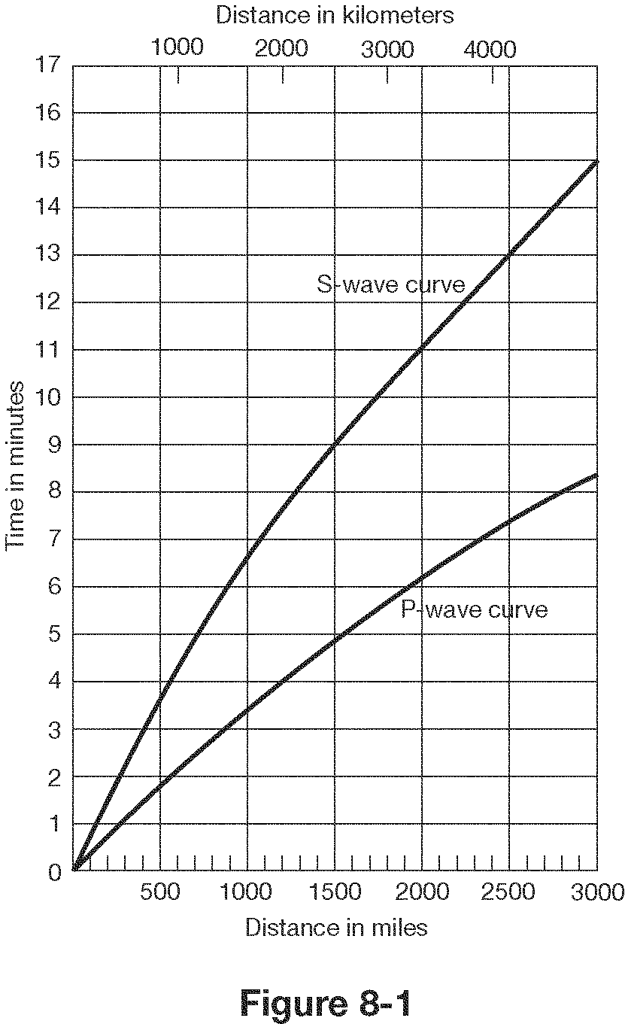

- How far does a P wave travel in 2 minutes? 550 miles (~1000 km)
- How far does an S wave travel in 4 minutes? 550 miles (~1000 km)
- How long does it take a P wave to travel 1500 miles?~5 minutes
- What is the lag time between P and S waves at 2000 km?~ 4 minutes
- What is the lag time for P and S waves at the epicenter?0 minutes
- If there is a lag time of 4.5 minutes between P and S waves, how far is the epicenter?~1700 miles (~2700 km)
- If there is a lag time of 2 minutes between P and S waves, how far is the epicenter?~ 650 miles (1050 km)

Write P, S or Surface(L)
- Fastest waves-_______P___
- Slowest waves-_______L___
- Only travel through solids-____S______
- Cause the most damage-_______L___
- Travel side to side-_______S___
- Push-Pull or compression waves-_____P_____
- Can’t make it through the outer core-___S (or L)_______

15. The difference in the arrival times__ of P waves and S waves is used to locate an earthquake’s epicenter.

16. The amount of damage that results from an earthquake depends on the intensity and duration of the earthquake, the nature of the material on which structures are built, and building material

17. Can we predict earthquakes? Not really, we can talk about the likelihood an area may get an earthquake

18. How do earthquakes provide evidence of plate tectonics? Happen on plate boundaries

19. List at least four dangers (factors affecting damage) that are associated with earthquakes.
Fire, landslide, tsunami, liquefaction, disease

20. How many seismic stations are needed to locate an earthquake? 3

21. What can we learn from earthquakes? Location of plate boundaries, interior of earth, type of plate boundary

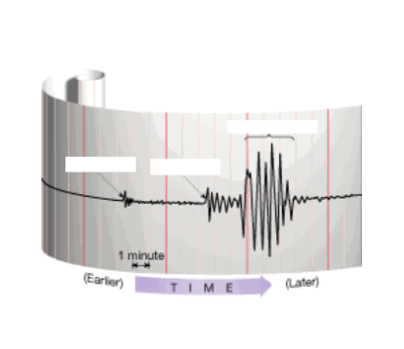
M.

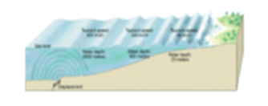
Match the following words with the correct definition and picture: Put both letters on the line.

N.
26. Seismogram - D,M a. sudden release of energy as deformed rock snaps
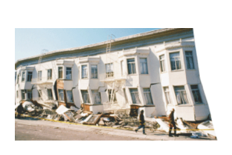
27.Lithosphere - E,T b. solid layer of Earth under the crust

28. Epicenter - H,S c. huge wave caused by an underwater earthquake
O.
29. Mantle - B,Q d. a recording of earthquake waves

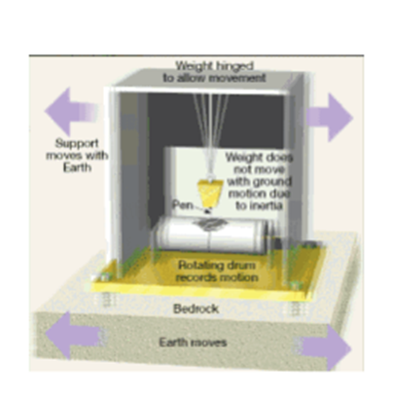
30. Asthenosphere - I,X e. rigid layer of Earth made of crust and the uppermost mantle

31. Fault - J,W f. solid innermost part of Earth, made of iron and nickel
P.
32. Focus - K,U g. liquid layer of the Earth, made of iron and nickel

33. Outer core - G,V h. surface location of an earthquake

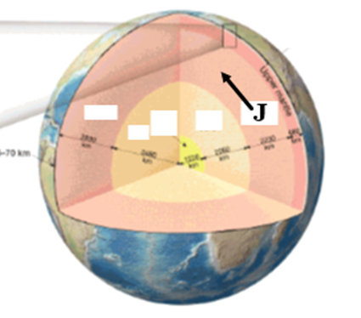
34. Seismograph - L,P i. semi-molten layer of Earth in the upper mantle

35. Tsunami - C,N j. crack in the Earth along which movement has occurred
Q.
36. Inner core - F,R k. underground location of an earthquake, point of origin

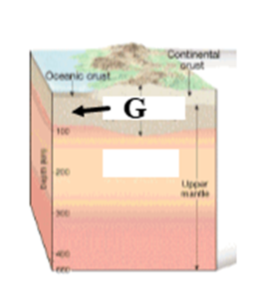
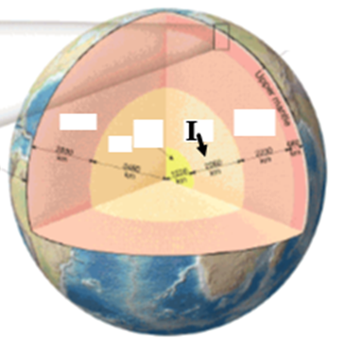
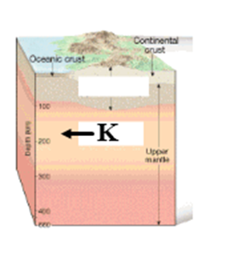
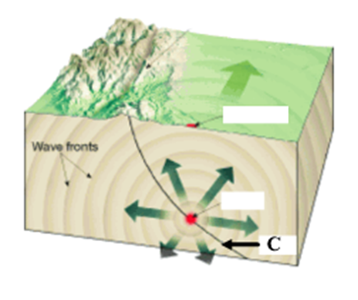
37. Earthquake - A,O l. devise that measures and records earthquake waves
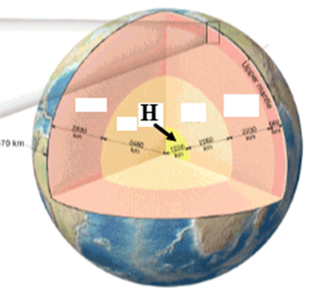
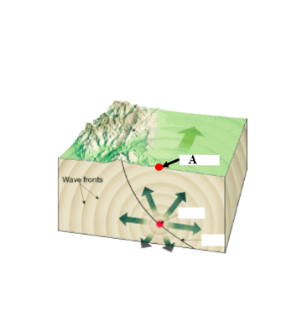
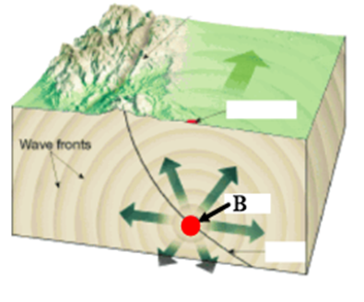

R. S. T. U. V. W. X.

38. What are the main pieces of evidence for plate tectonics? magnetic strips, mountains, climate, fit of continents, fossils

39. Most earthquakes and volcanoes take place at plate boundaries ?
40. The Mid-Atlantic Ridge, where plates are moving apart, is an example of a diverging boundary?
41. Crust is created at diverging boundaries and destroyed at converging boundaries.
42. The Himalayas where two continental plates are colliding is an example of a converging (collision) boundary and the Andes Mountains where an ocean plate is being pushed under a continental plate is an example of a converging (subduction) boundary, meaning the Andes mountains must be volcanic While the Himalayas are non-volcanic
43. Oceanic crust is always subducted under continental crust because it is more dense
44. Hawaii is not located on a plate boundary, but it is the most volcanically active place in the world due to a hot spot
45. How do volcanoes provide evidence of plate tectonics? Happen along with earthquakes on certain types of plate boundaries
46. What things influence the nature of a volcanic eruption?
Mainly viscosity of magma and amount of dissolved gasses in magma
What are some warning signs that a volcano may erupt? Volcano swells, more gas released, lakes become more acidic, more earthquakes
47. Which volcano below will have an explosive eruption and why?
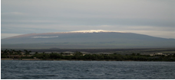
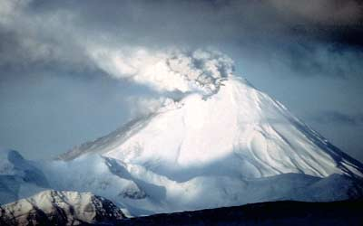

Steeper one, comes from viscous magma

Identify the boundaries, on the second line, identify the geologic feature(s) found there

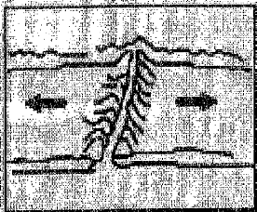
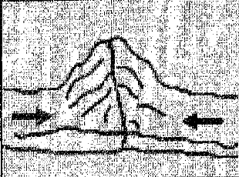
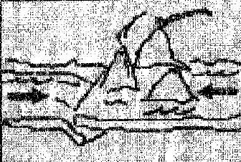
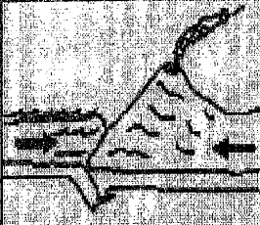

1. 2. 3. 4.
Diverging 4 Collision 1 Subduction (o&o) 2 Subduction (o&c) 3
Ocean ridge mountain trench / volcano trench / volcano

- Sea floor spreading is taking place at 4 (diverging) (above)

- Describe plate motions at:
    - Transform boundaries – slide past each other
    - Converging boundaries – move toward each other
    - Diverging boundaries - move away from each other
- What was discovered near the center of the Atlantic Ocean? Oceanic ridge

- What discovery was made in bands of rock on either side of the Mid-Atlantic Ridge? Magnetic strips of same age

52. How do these bands support sea-floor spreading? Show that they were once together and moved apart
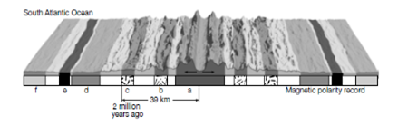

- Thickest sediments on sea floor F - oldest

- Which two letters are the same age? aa,bb,cc,dd,ee,ff

- Youngest rocks on sea floor a
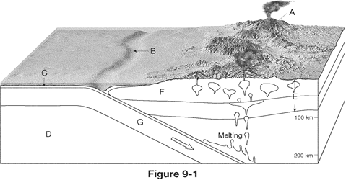
- What are some warning signs that a volcano may become active in the near future? Volcano swells, more gas released, lakes become more acidic, more earthquakes

- What type of boundary is shown above? Converging (subduction)
- What are the two geologic structures found in the diagram above? Trench / volcano

- Which crust is being subducted and why? Oceanic crust / it is more dense

- What is the cause of the volcanoes in the diagram? Melting of oceanic crust

