Earth’s Interior Test Honors 2017 Name **CLASS SET : DO NOT WRITE ON**

1. New ocean crust is formed at ____.

|  |  |  |  |
| --- | --- | --- | --- |
| a. | divergent boundaries | c. | continental volcanic arcs |
| b. | convergent boundaries | d. | transform fault boundaries |

2. Through which Earth layer are S waves NOT transmitted?

|  |  |  |  |
| --- | --- | --- | --- |
| a. | continental crust | c. | inner core |
| b. | ocean crust | d. | outer core |

3. The two structures always found at a subduction zone are:

|  |  |
| --- | --- |
| a. | Trench and ridge |
| b. | Ridge and magnetic strips |
| c. | Volcano and rift valley |
| d. | Trench and volcano |

4. How does the age of seafloor change with increasing distance from the ocean ridge?

|  |  |  |  |
| --- | --- | --- | --- |
| a. | Age decreases. | c. | Age increases. |
| b. | Age stays the same. | d. | Age varies without a pattern. |

5. Lava with high viscosity will flow

|  |  |  |  |
| --- | --- | --- | --- |
| a. | slowly | c. | not at all |
| b. | quickly | d. | uphill |

6. The geographic distribution of the swimming reptile *Mesosaurus* provides evidence that ____.

|  |  |
| --- | --- |
| a. | Europe was covered by a shallow sea when *Mesosaurus* lived |
| b. | a land bridge existed between Australia and India |
| c. | South America and Africa were once joined |
| d. | the Atlantic Ocean was wider when *Mesosaurus* lived than it is now |

7. Which of the following factors helps determine whether a volcanic eruption will be violent or relatively quiet? (mark all that apply)

|  |  |
| --- | --- |
| a. | amount of dissolved gases in the magma |
| b. | temperature of the magma |
| c. | composition of the magma |
| d. | height of volcano |

8. What kind of plate boundary occurs where two plates grind past each other without destroying or producing lithosphere?

|  |  |  |  |
| --- | --- | --- | --- |
| a. | divergent boundary | c. | transitional boundary |
| b. | convergent boundary | d. | transform fault boundary |

9. In which of the following areas would the damage from an earthquake measuring 6.8 likely be the greatest?

|  |  |
| --- | --- |
| a. | lightly populated rural area |
| b. | area with older brick structures |
| c. | area with modern steel-framed structures |
| d. | area with wood-framed structures |

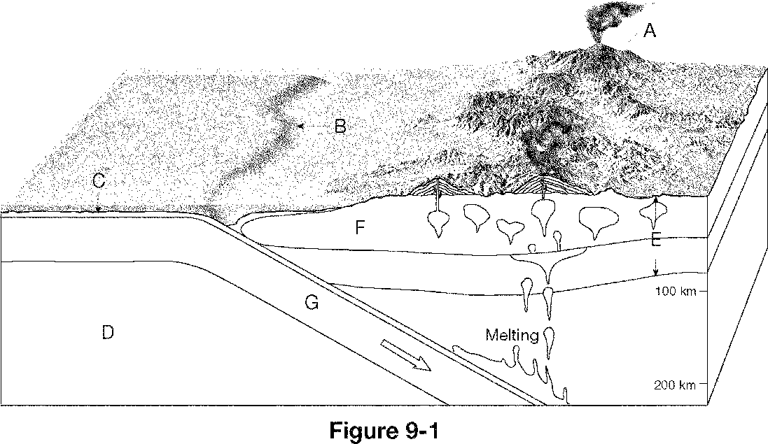

10. What type of plate boundary is illustrated in Figure 9-1?

|  |  |
| --- | --- |
| a. | transform fault boundary |
| b. | divergent boundary |
| c. | convergent oceanic-oceanic boundary |
| d. | convergent oceanic-continental boundary |

11. What feature is labeled B in Figure 9-1?

|  |  |  |  |
| --- | --- | --- | --- |
| a. | trench | c. | volcanic island arc |
| b. | ocean ridge | d. | continental volcanic arc |

12. What layer of Earth is labeled C in Figure 9-1?

|  |  |  |  |
| --- | --- | --- | --- |
| a. | asthenosphere | c. | oceanic crust |
| b. | continental lithosphere | d. | continental crust |

13. What process is illustrated by the area labeled G in Figure 9-1?

|  |  |  |  |
| --- | --- | --- | --- |
| a. | seafloor spreading | c. | rifting |
| b. | continental volcanism | d. | subduction |

14. Oceanic lithosphere is destroyed at ____.

|  |  |  |  |
| --- | --- | --- | --- |
| a. | transform fault boundaries | c. | ocean ridges |
| b. | divergent boundaries | d. | convergent boundaries |

15. What forms when one oceanic plate is forced beneath another plate?

|  |  |  |  |
| --- | --- | --- | --- |
| a. | an ocean basin | c. | a subduction zone |
| b. | an ocean ridge | d. | a rift valley |

16. Which of the following is NOT a factor affecting how violently or quietly a volcano erupts?

|  |  |
| --- | --- |
| a. | magma’s composition |
| b. | magma’s temperature |
| c. | concentration of dissolved gases in the magma |
| d. | size of the volcano’s cone |

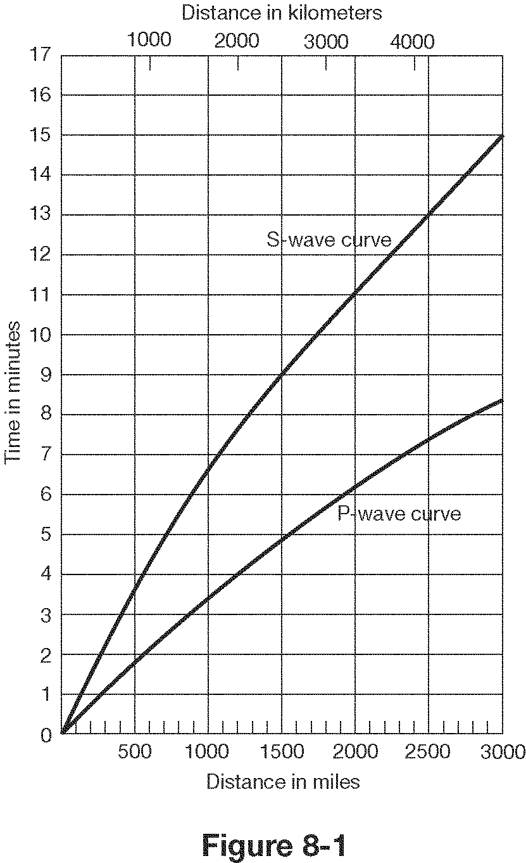

17. According to Figure 8-1, what is the distance between the seismic station and an earthquake epicenter, if the first S wave arrives 4.0 minutes after the first P wave?

|  |  |  |  |
| --- | --- | --- | --- |
| a. | 1500miles | c. | 3000miles |
| b. | 2500 miles | d. | 2000 miles |

18. According to Figure 8-1, when will the first P wave be received, if an earthquake epicenter is approximately 1000 miles from the seismic station?

|  |  |
| --- | --- |
| a. | 3.5 minutes after the earthquake |
| b. | 5.5 minutes after the earthquake |
| c. | 6.6 minutes after the earthquake |
| d. | 10.5 minutes after the earthquake |

19. Use the graph in Figure 8-1 to determine the difference in the travel-times between the first P wave and the first S wave, if the seismic station is 4000 **kilometers** from the epicenter.

|  |  |  |  |
| --- | --- | --- | --- |
| a. | 10.0 minutes | c. | 5.2 minutes |
| b. | 4.5 minutes | d. | 4.2 minutes |

20. The Hawaiian Islands were formed when the Pacific Plate moved over ____.

|  |  |  |  |
| --- | --- | --- | --- |
| a. | a subduction zone | c. | the Aleutian Plate |
| b. | an ocean ridge | d. | a hot spot |

21. What type of boundary occurs where two plates move together, causing one plate to descend into the mantle beneath the other plate?

|  |  |  |  |
| --- | --- | --- | --- |
| a. | transform fault boundary | c. | convergent boundary |
| b. | divergent boundary | d. | transitional boundary |

22. The distance between a seismic station and the earthquake epicenter is determined from the ____.

|  |  |
| --- | --- |
| a. | calculation of the earthquake magnitude |
| b. | intensity of the earthquake |
| c. | arrival times of P and S waves |
| d. | measurement of the amplitude of the surface wave |

23. Why are subduction zones not commonly found at convergent continental-continental boundaries?

|  |  |
| --- | --- |
| a. | Continental lithosphere is too buoyant to be forced down into the mantle. |
| b. | Subduction zones are never found at convergent boundaries. |
| c. | Oceanic lithosphere is too buoyant to be forced down into the mantle. |
| d. | Continental lithosphere is too dense to be forced down into the mantle. |

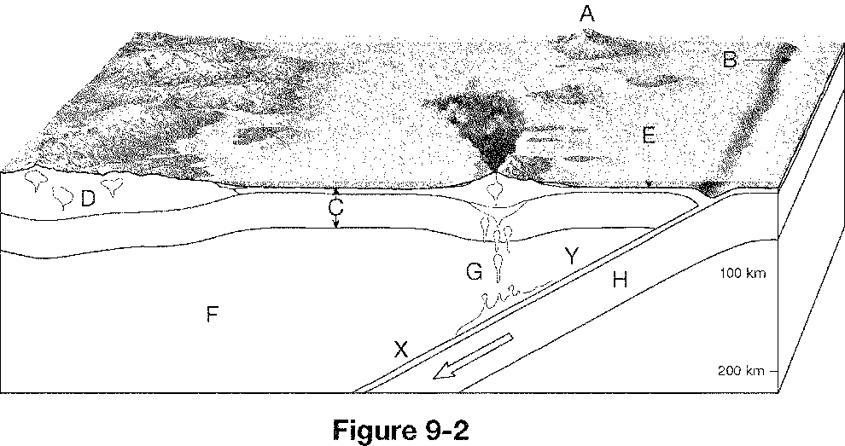

24. What type of plate boundary is illustrated in Figure 9-2?

|  |  |
| --- | --- |
| a. | divergent boundary |
| b. | convergent oceanic-continental boundary |
| c. | convergent continental-continental boundary |
| d. | convergent oceanic-oceanic boundary |

25. What is the driving force for volcanic eruptions?

|  |  |  |  |
| --- | --- | --- | --- |
| a. | dissolved gases | c. | high temperatures |
| b. | viscous magma | d. | Plates pushing up |

26. Which of the following affects the amount of destruction caused by earthquake vibrations? (Mark all that apply)

|  |  |
| --- | --- |
| a. | the design of structures |
| b. | the intensity and duration of the vibrations |
| c. | the distance from the epicenter |
| d. | the nature of the material on which structures are built |

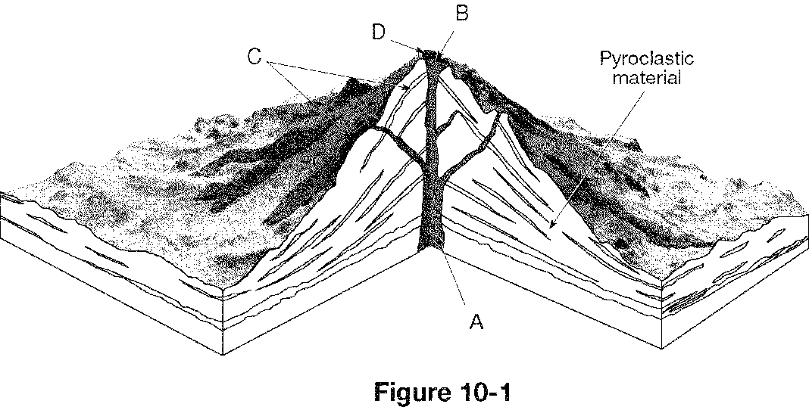

27. What type of volcano is illustrated in Figure 10-1?

|  |  |  |  |
| --- | --- | --- | --- |
| a. | volcanic neck | c. | cinder cone |
| b. | shield volcano | d. | composite cone |

28. The volcano in Figure 10-1was formed from magma and will have eruptions.

|  |  |  |  |
| --- | --- | --- | --- |
| a. | Viscous, gentle | c. | Viscous, explosive |
| b. | Non-viscous, explosive | d. | Non-viscous, gentle |



**Figure 9-3**

29. What type of boundary is shown in the diagram above (Figure 9-3)?

|  |  |  |  |
| --- | --- | --- | --- |
| a. | converging oceanic-continental | c. | diverging oceanic-oceanic |
| b. | diverging continental-continental | d. | converging continental-continental |

30. A succession of ocean waves set in motion by a submarine earthquake is called a(n) ____.

|  |  |  |  |
| --- | --- | --- | --- |
| a. | compression wave | c. | tsunami |
| b. | underwater landslide | d. | liquefaction |



**Figure 9-4**

31. What is happening in the diagram above (Figure 9-4)?

|  |  |  |  |
| --- | --- | --- | --- |
| a. | subduction | c. | convergence |
| b. | seafloor spreading | d. | continental creation |

32. In Figure 9-4, what structure has formed at the end of the process shown above (labeled D)?

|  |  |  |  |
| --- | --- | --- | --- |
| a. | oceanic trench | c. | volcanic island arc |
| b. | rift valley | d. | mid-ocean ridge |

33. Long-range earthquake forecasts are based on the idea that earthquakes are ____.

|  |  |  |  |
| --- | --- | --- | --- |
| a. | random | c. | fully understood |
| b. | destructive | d. | repetitive |

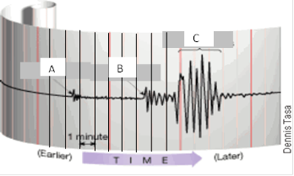

C

**Figure 8-2**

34. In Figure 8-2 above, what is wave B called?

a. Surface wave c. P- wave

b. S- wave d. L- wave

35. What is the difference in arrival times for the P- wave and S- wave in Figure 8-2?

a. 3.5 minutes c. 5 minutes

b. 4 minutes d. 6.5 minutes

36. Use Figure 8-1 to determine the distance that the seismogram (Figure 8-2) is from the epicenter.

a. 1600 miles c. 2100 miles

b. 1250 miles d. 2900 miles

37. Why do earthquakes often cause damaging fires?

|  |  |
| --- | --- |
| a. | Lightning strikes are common during earthquakes. |
| b. | Earthquake vibrations can break gas lines, water lines, and electrical lines. |
| c. | Tsunamis from earthquakes generate enough heat to start fires. |
| d. | Magma from deep underground escapes through faults. |

38. What information **cannot** be learned about Earth from the depth of focus of earthquakes in a particular area?

|  |  |
| --- | --- |
| a. | the type of plate boundary found there |
| b. | direction the plates are moving |
| c. | when future earthquake will occur |
| d. | location of faults |

39. Which one of the following statements is true about P waves?

|  |  |
| --- | --- |
| a. | They travel only through solids. |
| b. | They travel faster than S waves. |
| c. | They are the most destructive type of seismic wave. |
| d. | They cannot be recorded on a seismograph. |

40. Tsunamis are ____.

|  |  |
| --- | --- |
| a. | often generated by movements of the ocean floor |
| b. | waves that are produced by tidal forces |
| c. | waves that cannot cause damage on land |
| d. | also known as tidal waves |

41. Most of the information about Earth’s interior was obtained by studying ____.

|  |  |  |  |
| --- | --- | --- | --- |
| a. | earthquake waves | c. | meteorites |
| b. | rocks of the ocean crust | d. | rocks in deep wells |

42. What is the minimum number of seismic stations that is needed to determine the location of an earthquake’s epicenter?

|  |  |  |  |
| --- | --- | --- | --- |
| a. | two | c. | four |
| b. | one | d. | Three |

43. The Himalayas in South Asia are non-volcanic mountains and must therefore be an example of what type of plate boundary?

|  |  |
| --- | --- |
| a. | convergent oceanic-continental boundary |
| b. | convergent continental-continental boundary |
| c. | divergent boundary |
| d. | transform fault boundary |

44. Which of the following areas would most likely be the safest during a major earthquake?

|  |  |
| --- | --- |
| a. | area with granite bedrock |
| b. | area with loosely consolidated soil |
| c. | area with structures built on a landfill |
| d. | area with steep slopes of unconsolidated sediments |

45. The hypothesis that explains the release of energy during an earthquake is called the ____.

|  |  |  |  |
| --- | --- | --- | --- |
| a. | Richter hypothesis | c. | vibration hypothesis |
| b. | moment magnitude hypothesis | d. | elastic rebound hypothesis |

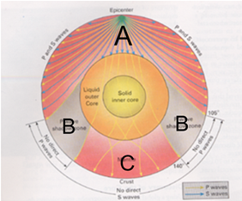

**Answer TWO of the following (5 points each)**

1. Use the diagram to the right and explain what is

seen at A,B, and C and how this information tells geologists

what the interior of the Earth is like.

At point A, we see P and S waves travelling through the Earth. At point B, we do not see any direct waves. At point C, we see only P waves. B and C show that the outer core is a liquid. The S waves do not make it through to C because they cannot travel through a liquid, but the P waves can. This shows there must be a liquid in between and the size of C indicates the size of the outer core. At B, the shadow exists because the P waves are refracted when hitting the liquid outer core which supplies further evidence of the liquid outer core and its size provides evidence for the size of the solid inner core.

2. Two moderate earthquakes measuring 6.1 on the Richter scale strike in two different locations on Earth. There is damage in both locations, but at one site, the damage and death toll is far greater. Explain why there could be such a big difference. Give at least three possible reasons and examples to justify each. Answers will vary:

Needed to provide examples:

Tsunami- more damaged city is on the coast and there was a tsunami

Construction- more damaged city has brick / concrete which crumbles, less damaged city has steel which bends.

Distance – more damaged city was closer to the epicenter.

Duration – more damaged city had to endure shaking for longer period of time which led to more damage.

Bedrock- more damaged city was on ancient lake bed which amplifies ground motion, while less damaged city was on solid granite which diminishes shaking.

ETC…

3. The diagram below is the strongest piece of evidence for Plate Tectonics. Explain what it shows. Be sure to explain the letters and the bands and how they show that the plates are moving.

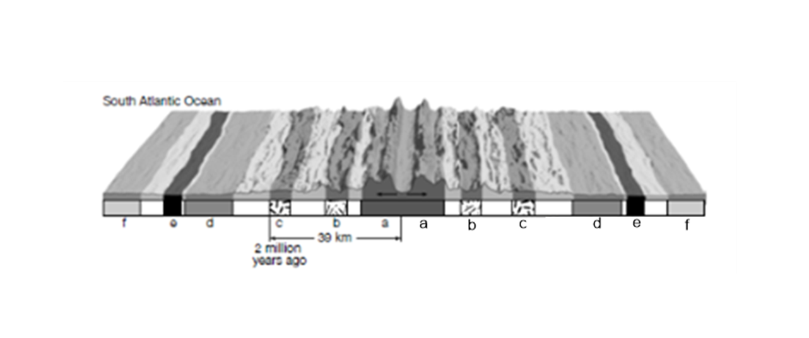

The same lettered bands shown are the same size, distance from the ridge, age, and magnetic polarity. For examplea and a, b and b, c and c, etc.. are the same..This indicates that they were at one time connected. They also increase in age as you move away from the ridge which shows that the new oceanic lithosphere is being created at the ridge in the center.

4. What could be some warning signs (**name 3**) that the

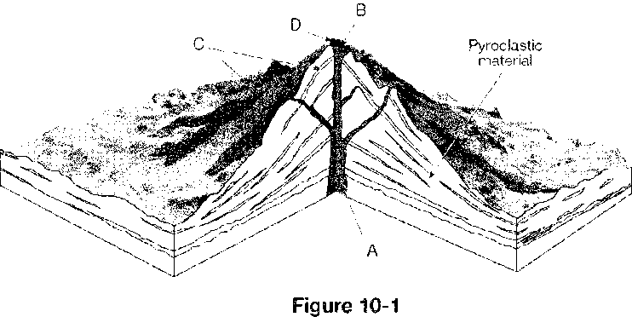volcano in Figure 10-1 might erupt in the near

future? Be sure to explain the significance of

the warning sign.

If the volcano in the picture were getting ready to

erupt, some warning signs might include; increase in

the number of earthquakes, increase in lake acidity,

bulging in the mountain itself, and an increase in outgassing.

The earthquakes may indicate magma moving under the volcano. The increased acidity might indicate more gasses bubbling through the lakes which mean more gas present in the volcano so pressure could be building. The bulging in the mountain may indicate the pressure within the volcano is building because the gasses cannot escape. The increased outgassing may indicate there is more magma in the volcano which is leading to more gasses escaping and those gasses may build pressure.

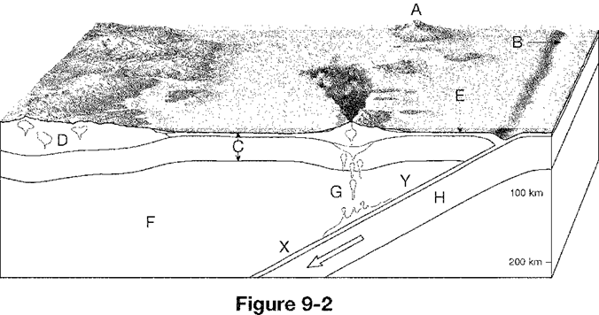

5. Describe what the structures labeled A and B

in Figure 9-2 are and explain the cause for them.

A is a volcanic island and b is a deep sea trench. A is

formed from the melting of the subducting oceanic

plate H. As it descends and melts the magma then

rises up creating volcanic islands. B is formed as the

subducting oceanic plate H pulls down the leading

edge of the other oceanic plate C.