Earth’s Interior Test A NAME

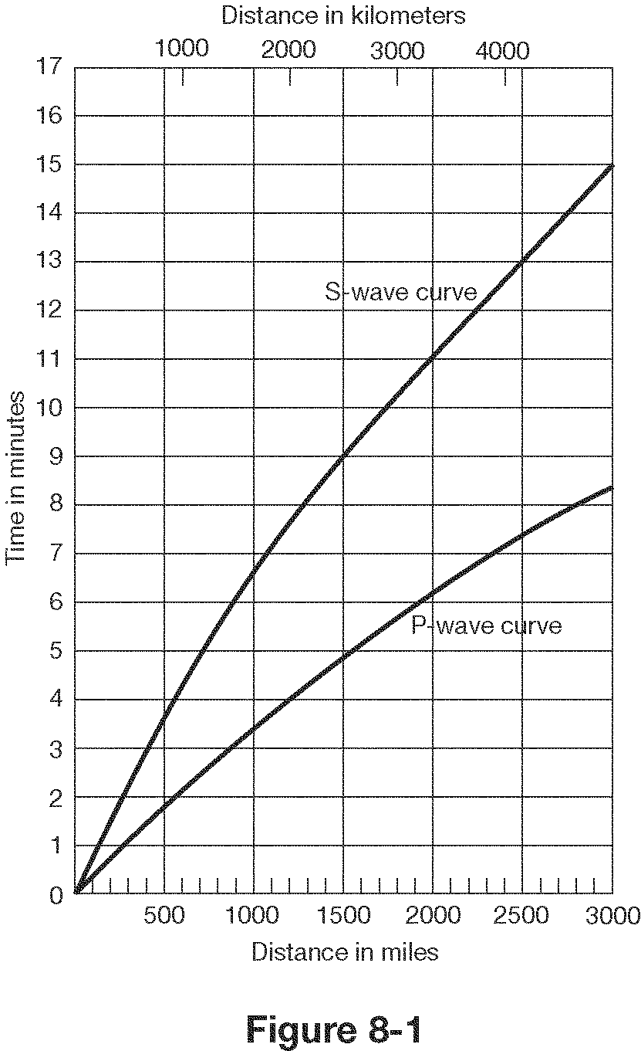

1.How far does a P-wave travel in 5 minutes?
a. 1550 miles (2600 km) c. 2400 miles (4000 km)
b. 1100 miles (1750 km) d. 3000 miles (4800 km)

2.How long does it take an S-wave to travel 1800 miles (3000 km)?
a. 10 minutes 10seconds c. 5 minutes 15 seconds
b. 14 minutes 30 seconds d. 3 minutes 10 seconds

3.What is the distance to the epicenter if there is a 4 minute lag time?
a. | 1800 miles (3000 kilometers) | c. 900 miles (1500 kilometers)
b. | 1380 miles (2300 kilometers) | d. 500 miles (800 kilometers)

4.How long does it take a P-wave to travel 1100 miles (1800 km)?
a. | 3.5 minutes after the earthquake
b. | 6.6 minutes after the earthquake
c. | 10.5 minutes after the earthquake

5.What is the lag time for P and S – waves, if the seismic station is 2400 miles (4000 km) from the epicenter.
a. | 10.0 minutes |  | c. | 5.5 minutes
b. | 4.0 minutes

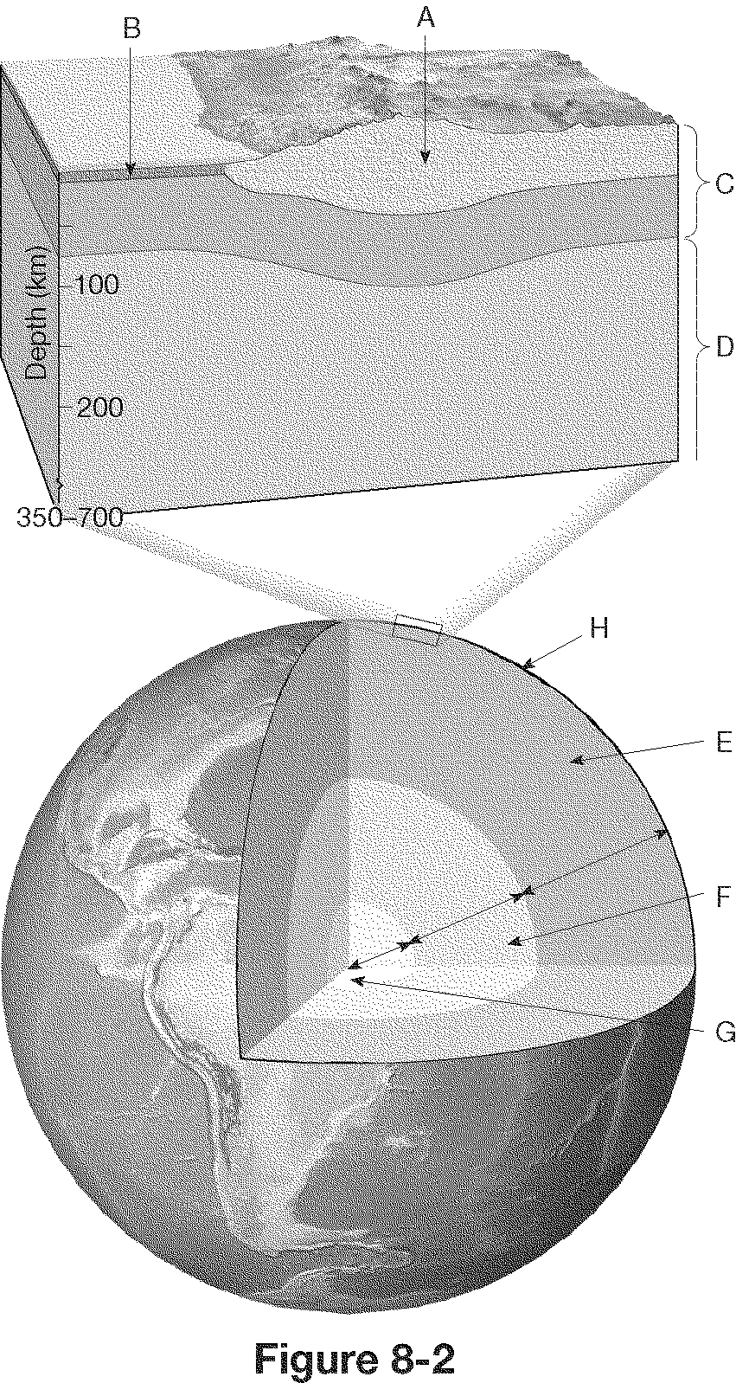

6.What layer is labeled C, (makes up the plates on Earth) in figure 8-2?
a. | the mantle | c. outer core
b. | the lithosphere | d. | asthenosphere

7. What layer of Earth is labeled E, (greatest volume of Earth’s interior) in Figure 8-2?
a. | the oceanic crust | c. the mantle
b. | the lithosphere | d | the outer core
D

8. How many seismograms are needed to locate an earthquake’s epicenter?
a. | six | c. three
b. | one | d. five

10. Which seismic waves only travel through solids?
a. | P waves | c. | surface waves (L)
b. | S waves
d

11. Which of the following areas would most likely be the safest during a major earthquake?
a. | area with granite bedrock
b. | area with loosely consolidated soil
c. | area with structures built on a landfill
d. | area with steep slopes of unconsolidated sediments

12. Can we predict earthquakes?
a. | Yes, we can tell when and where they will occur weeks in advance
b. | Yes, but only in giving a probability that an area will have one
c. | No, earthquakes are completely random events that can’t be predicted

13. In places like Mexico City, earthquakes can turn solid soil into a fluid through a process called ____.
a. | tidal effect | c. | liquefaction
b. | underwater landslide

14. Tsunamis are ____.
a. | Formed by underwater earthquakes
b. | waves that are produced by tidal forces
c. | waves that cannot cause damage on land
15. In which of the following areas would the damage from an earthquake measuring 6.8 likely be the greatest?
a. | lightly populated rural area
b. | area with older brick structures
c. | area with modern steel-framed structures
d. | area with wood-framed structures

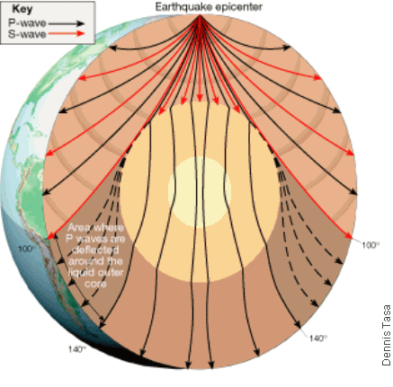

16. Which layer will S-waves NOT go through?
a. | continental crust | c. | inner core
b. | outer core

17. In the picture above, what happens to the P waves as they travel through the outer core?
a. | they change direction
b. | they stop
c. | they bounce off
d. | they all go straight through

18. Which of the following affects the amount of destruction caused by earthquake vibrations?
a. | the design of structures
b. | the intensity and duration of the vibrations
c. | the nature of the material on which structures are built
d. | all of the above

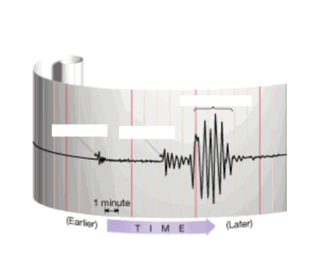
For 19 – 25, Put the letter of the correct definition and the letter of the correct picture:

19. Focus - D/I__ A. a weak plastic layer of the mantle H.
situated below the lithosphere

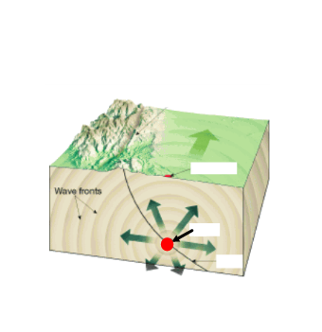

20. Surface Wave - E/N__ B. the Japanese word for a seismic I.
sea wave
I

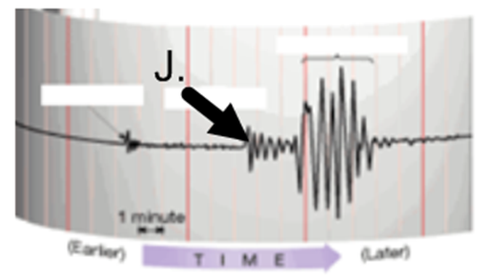
21. Elastic Rebound - _G/K_ C. the record made by a seismograph .
J

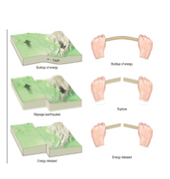
22. Asthenosphere - A/M__ D. the point within Earth where an K.
earthquake originates

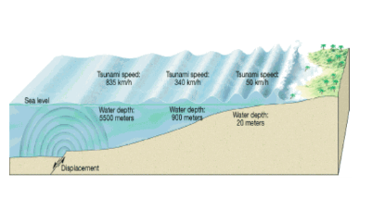
23. Seismogram - C/H__ E. a seismic wave that travels along L.
the surface of Earth

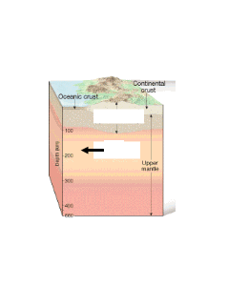
24. S-Wave - _F/J__ F. a seismic wave that shakes particles
perpendicular to the direction the wave
is traveling
M

N
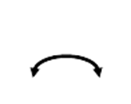
25. Tsunami - B/L G. the explanation stating that when rocks
are deformed, they break, releasing the
stored energy that results in the vibrations
of an earthquake

26. Strips of alternating magnetic polarities found in rocks in the ocean basins ____.
a. | conflict with the theory of plate tectonics
b. | provide evidence that Earth’s magnetic field has never reversed polarity
c. | indicate changes in Earth’s gravitation field
d. | provide evidence for seafloor spreading

27. New ocean crust is formed at ____.
a. | divergent boundaries | c. | continental volcanic arcs
b. | convergent boundaries | d. | transform fault boundaries

28. Lava with high viscosity will flow
a. | slowly | c. | not at all
b. | quickly | d. | uphill

29. What kind of plate boundary occurs where two plates grind past each other without destroying or producing lithosphere?
a. | divergent boundary | c. | transitional boundary
b. | convergent boundary | d. | transform fault boundary

30. What forms when one oceanic plate is forced beneath another plate?
a. | an ocean basin | c. | a subduction zone
b. | an ocean ridge | d. | a rift valley

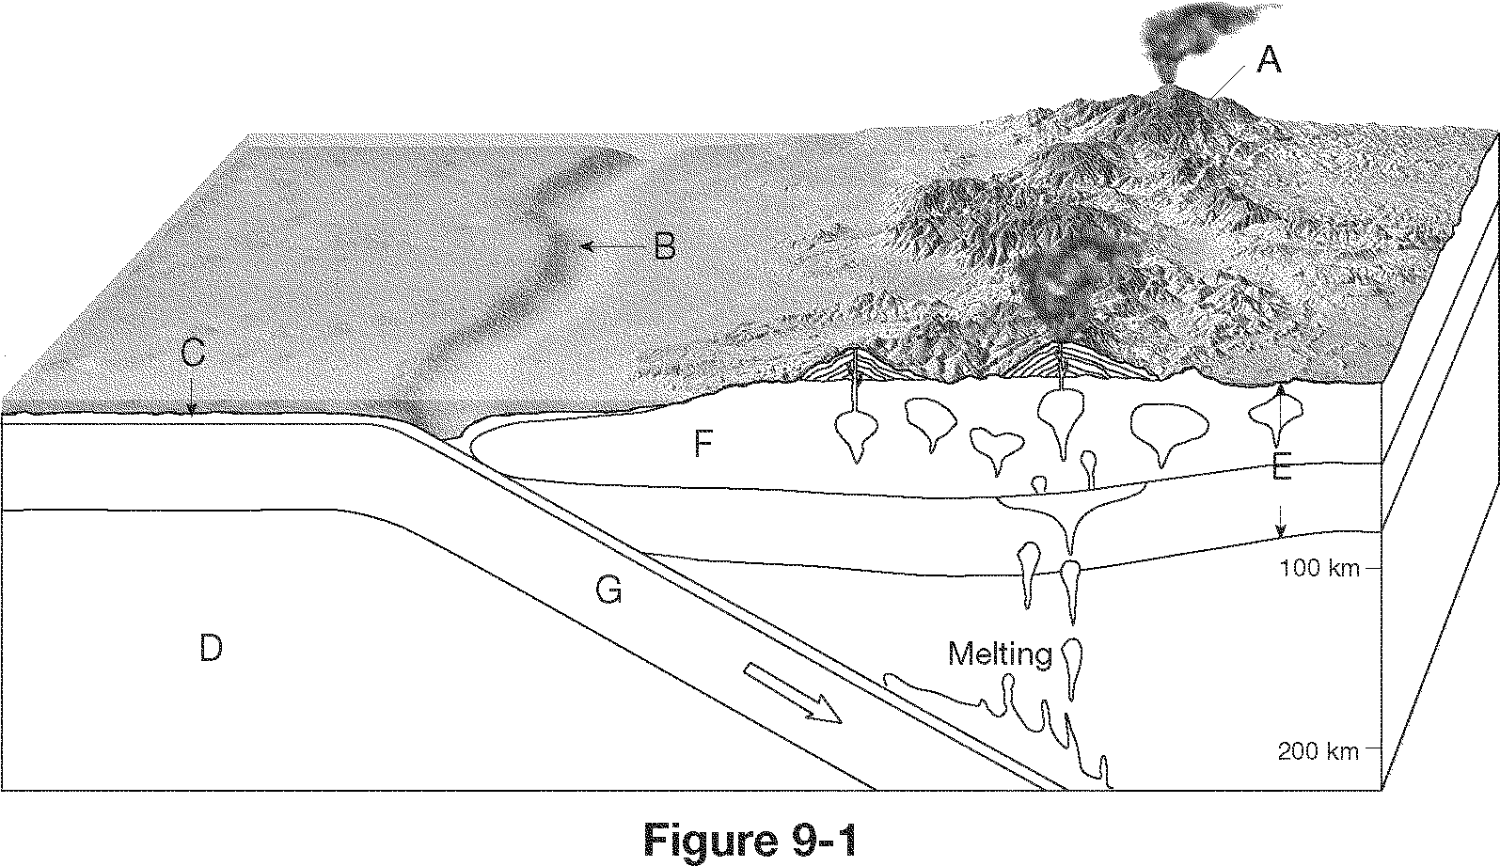

31. What type of plate boundary is illustrated in Figure 9-1?
a. | transform fault boundary
b. | divergent boundary
c. | convergent oceanic-oceanic boundary
d. | convergent oceanic-continental boundary

32. What feature is labeled B in Figure 9-1?
a. | trench | c. | volcanic island arc
b. | ocean ridge | d. | continental volcanic arc

33. How does the age of seafloor change with increasing distance from the ocean ridge?
a. | Age decreases. | c. | Age increases.
b. | Age stays the same. | d. | Age varies without a pattern.
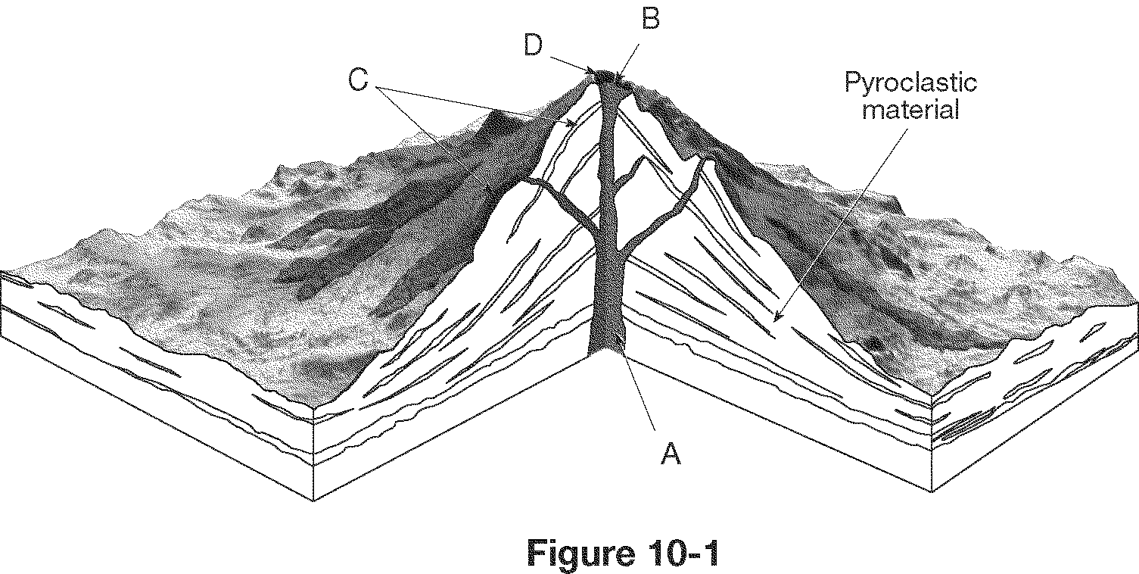

34. What type of volcano is illustrated in Figure 10-1?
a. | volcanic neck | c. | cinder cone
b. | shield volcano | d. | composite cone

___
35. What type of eruption will the volcano in Figure 10-1 have?
a. | gentle | c. | small
b. | explosive | d. | impossible to tell

36. What type of magma does the volcano above have based on its shape?

a. thin c. non-viscous
b. viscous d. non-gassy
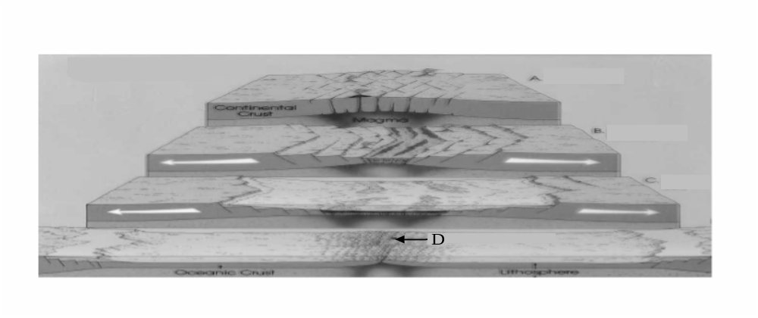

37. What process is being shown in the diagram above?
a. | subduction | c. | seafloor spreading
b. | mountain building | d. | convergence

38. What structure has formed at the end of the process shown above (labeled D)?
a. | oceanic trench | c. | volcanic island arc
b. | rift valley | d. | mid-ocean ridge

39. Which of the following is not evidence of Plate Tectonics?
a. location of earthquakes c. location of volcanoes
b. magnetic bands on ocean floor d. similar fossils on separate continents
e. all of the above are evidence of plate tectonics

40. What can we learn from earthquakes, mark all that apply?
a. distance of earthquakes c. magnitude of earthquakes
b. age of Earth d. Earth’s interior layers
e. temperature of Earth

41. Most earthquakes and volcanoes take place at ?
a. coastlines c. city centers
b. plate boundaries d. state lines

42. The Himalayas where two continental plates are colliding is an example of a boundary and the mountains are
a. diverging, volcanic c. converging, volcanic
b. converging, non-volcanic d. transform fault, non-volcanic

43. Oceanic crust is always subducted under continental crust because it is
a. thicker c. more dense
b. thinner d. less dense

44. What things influence the nature of a volcanic eruption (mark all that apply)?
a. amount of dissolved gas c. viscosity of magma
b. location on Earth d. amount of venting from volcano

45. Which volcano below will have an explosive eruption and why?
a. 1, lava is more viscous
b. 2, lava is more viscous 1 2
c. 1, lava has less gas
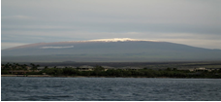
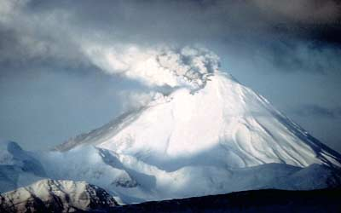
d. 2, lava is hotter

46. Which of the following is true about the bands in the picture below in providing evidence for plate tectonics (mark all that apply)?
a. the matching letters are the same age
b. the matching letters are the same distance from the center
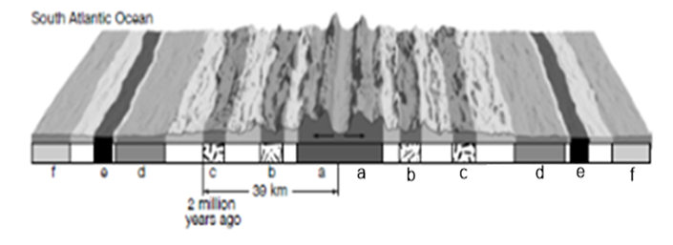
c. the matching letters have the same magnetic field
d. the matching letters are about the same size

47. Which two letters are the youngest in the diagram above?
a. a and a c. c and c
b. b and b d. d and d

48. What are some warning signs that a volcano like the one below may become active in the near future?
a. more outgassing, more earthquakes, expansion of the mountain
b. less outgassing, fewer earthquakes, expansion of the mountain
c. same outgassing, more earthquakes, contraction of the mountain
d. none of these are indicators, volcanoes are completely unpredictable

49.What type of boundary is shown in the diagram below?
a. converging, continental – continental c. subduction, oceanic – continental
c. transform fault, oceanic – oceanic d. diverging, oceanic - continental
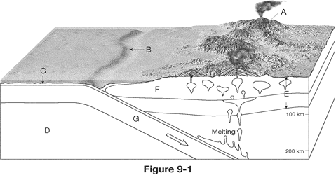

50. What are the two geologic structures found in the diagram above?
a. trench and volcano c. ridge and rift
b. volcano and canyon d. rift and mountain

