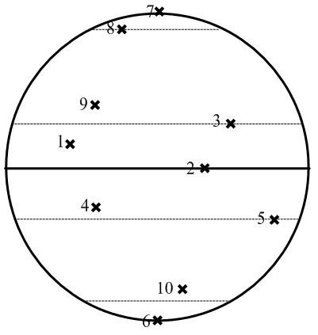
Earth’s Orientation in Space

1. When would you expect to see the Sun directly overhead at 12:00 Noon at point 1?
a. Jan. 10 b. Feb. 27 c. Sep. 10 d. Aug. 15

2. When would you expect to see the Sun directly overhead at 12:00 Noon at point 2?
a. Jan. 10 b. June 18 c. Nov. 5 d. Sep. 22

3. When would you expect to see the Sun directly overhead at 12:00 Noon at point 3?
a. June 21 b. Dec. 21 c. Sep. 22 d. Mar. 21

4. When would you expect to see the Sun directly overhead at 12:00 Noon at point 4?
a. Jan. 15 b. June 18 c. Sep. 9 d. May. 22

5. When would you expect to see the Sun directly overhead at 12:00 Noon at point 5?
a. June 21 b. Dec. 21 c. Sep. 22 d. Mar. 21

6. You can expect 24 hours of daylight at point 6 on which day?
a. Sep. 2 b. Dec. 12 c. June 13 d. March 1

7. You can expect 24 hours of night at point 7 on which day?
a. Dec. 15 b. Aug. 3 c. March 2 d. Sep. 18

8. When would you expect to have 24 hours of daylight at point 8?
a. June 21 b. Dec. 21 c. Sep. 22 d. Mar. 21

9. There are about 12 hours of day and night at point 9 on which day?
a. Jan. 10 b. March 21 c. Feb. 9 d. Dec. 22

10. There is only about 5 hours of daylight at point 10 on which day?
a. June 21 b. Dec. 21 c. Sep. 22 d. Mar. 21

