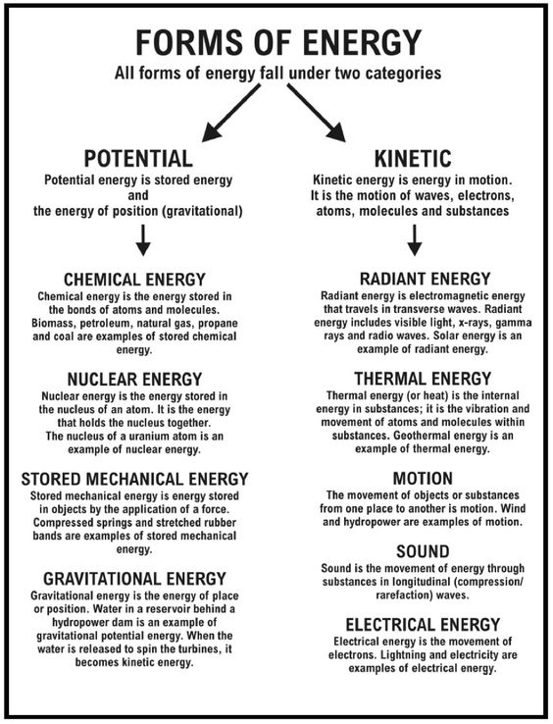

Name
Energy | Pe or KE | Type
example: Lightning | KE | Electrical
A- Wind
B- Matches
C- Coal
D- Lamp light
E- Suspended
Pendulum
F- Battery
G- Cold Pack
H- Food
I- Hot Plate
J- Stretched Elastic
K- Struck Tuning Fork
L- Inflated balloon
M- Compressed Toy Car
N- Electric Lamp

