Graph Interpretation Name

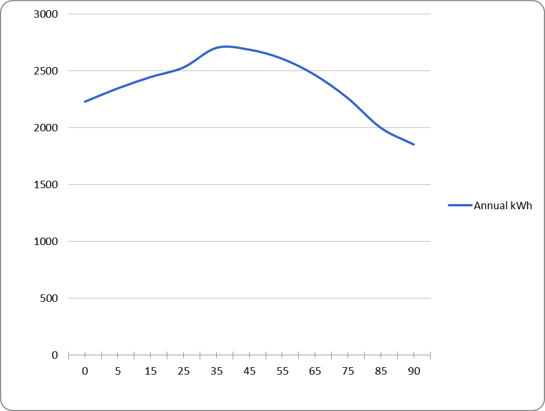

An experiment was run in order to see how the tilt angle of solar panels would affect the amount of energy (kWh) the panels produced. Above is a graph of the data gathered.
1. What is the independent variable? Where does it belong on the graph?
2. What is the dependent variable? Where does it belong on the graph?
3. What should be some constants?
Label the axis above and give the graph a proper title
4. What is the best angle for the panels to produce the most energy?
5. Interpret the graph, as the angle of the panels increases from 0 to 90 degrees, the energy
6. How much energy is produced at an angle of 75º?
7. At what angle will 2000 kWh be produced?
8. At 100º, how much energy would be produced?
9. Assume this graph is from a time in the spring, how would it be different in winter?
10. How would it differ in summer?

