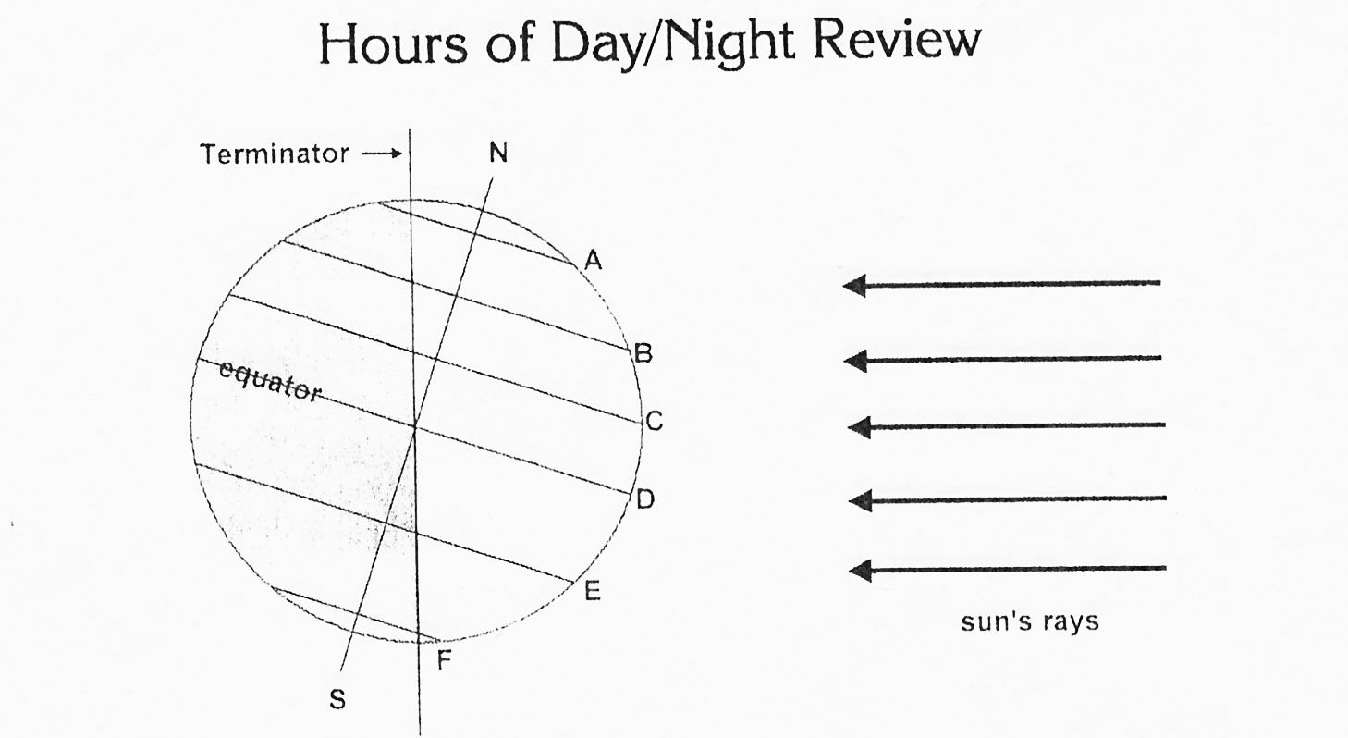
Name _________________ Block___

The diagram shows Earth and 6 locations, A – F, on the surface. The sun’s rays are also shown. The “terminator” is the line that divides the day from night. In the diagram the nighttime side of earth is on the left of the terminator line. Shade the earth to the left of the terminator line to show that part is experiencing night time.
Example Question: How many hours of daylight will a person located at D receive on the day of the year this diagram represents?
- Look at the line of latitude at which a letter is located.

$$\%= \frac{length of line in sunlight}{length of entire line}$$

$$hrs=24*\%$$
- Ask yourself, “What percent of this line is in the daylight?”
- That is the percent of 24 hours in a day that will be daylight at that location.
Use the steps in the sample problem to solve these questions. Show your work!

- How many hours of daylight will a person receive at location A?

- How many hours of daylight will a person receive at location B?

- How many hours of daylight will a person receive at location C?

- How many hours of daylight will a person receive at location E?

- How many hours of daylight will a person receive at location F?

- Where would a person have to stand to receive 24 hours of sunlight? __________________________

- To experience 24 hours of darkness? __________________________________________________

