Parallax and Kepler’s Laws NAME

SHOW ALL WORK
R = 1 / θ or θ = 1 / R R is distance in parsecs , θ is parallax angle in seconds
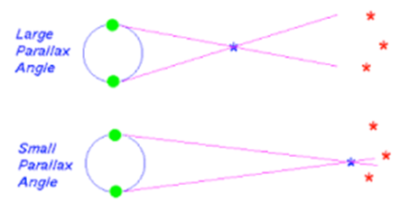
1. What is the parallax of a star that is 23 parsecs away?

2. What is the parallax of a star that is 50 parsecs away?

3. Star A has a parallax of 0.02” and star B has a parallax of 0.05”, which star is closer?

4. What is the distance of a star that has a parallax of 0.25”?

5. What is the distance of a star with a parallax of 0.1”?

6. Star 1 is 4 parsecs away and star 2 is 6 parsecs away, which star has a greater parallax?

P² ≈ a³ P is period in years, a is distance in AU’s

1. How long does it take Mars to orbit the Sun if it is an average distance of 1.524 AU’s?

2. How long does it take Eris to orbit the Sun if it is an average distance of 68 AU’s?

3. Jupiter is 5.203 AU’s from the Sun, how long does it take to orbit?

4. How far away is Saturn if it takes 29.46 years to orbit?

5. Haley’s comet orbits the Sun about every 76 years, what is the average distance of Haley’s comet?

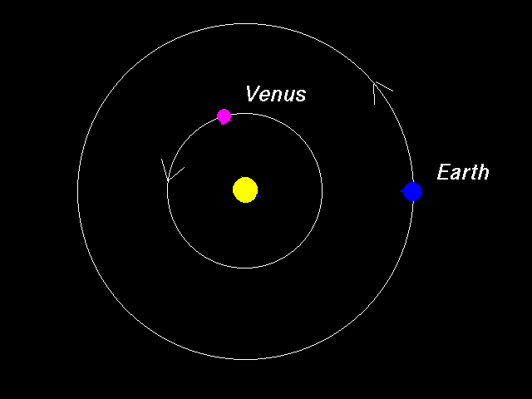
6. Venus is at an average distance of 0.723 AU’s from the Sun.
Calculate the average speed of Venus in its orbit around the Sun.
A. How long does it take Venus to orbit the Sun?

B. Convert the time in years it takes Venus to orbit the Sun
into hours. Remember that there are 365.25 days in a year
and 24 hours in a day.

C. How far does Venus travel in its orbit around the Sun? The distance is equal to the circumference of the circle Venus makes in its orbit. C = 2πr

D. Convert the distance above to km. There are 150,000,000 km in 1 AU.

E. You can now calculate the speed of Venus in its orbit around the Sun using the formula v = d / t.

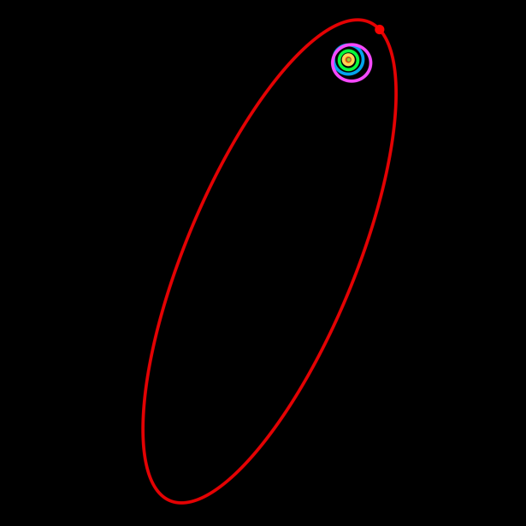
7. Use the steps as those used in question 6 to calculate the average speed of Sedna in its orbit around the Sun at an average distance of 506.5 AU’s. Show all work
A.

B.

C.

D.

E.

8. Use the steps as those used in question 6 to calculate the average speed of Ceres in its orbit around the Sun at an average distance of 2.77 AU’s. Show all work
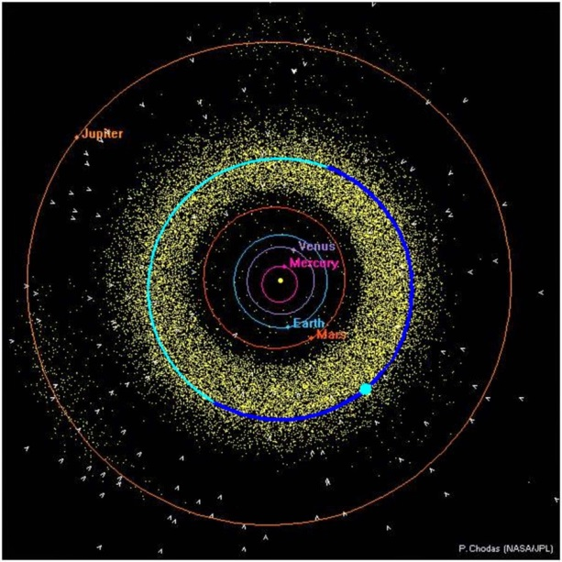
A.

B.

C.

D.

E.

