R = 1 / θ or θ = 1 / R where R is distance in parsecs and θ is parallax in seconds
P² = a³ where P is period in years and a is distance in AU’s
F = G m₁ m₂ / d² where F is force of gravity, m₁ and m₂ are masses, G is a gravitational constant, and d is the distance between them
F = ma where F is force in N, m is mass in kg, and a is acceleration in m/s²
V = d / t where V is velocity, d is distance in km, t is time in hours

1. What is the parallax of a star located 15 parsecs away?

2. A star that has a parallax of 0.03” is how far away?

3. What is the period of a comet that is an average distance of 9 AU’s?

4. What is the distance of an asteroid that has a period of orbit of 15 years?

5. What is the acceleration of a 20 kg object when a force of 30 N is applied?

6. What is the mass of an object that accelerates 5 m/s² when a force of 8 Newtons is applied to it?

7. What is the force of gravity between a 80 kg mass and a 30 kg mass that are separated by 3 km?
t/t☼ = (M/M☼) / (L/L☼)

8. What is the relative lifespan of a star with mass of 4M☼ and brightness of 24L☼?

9. A star has a brightness of 0.2L☼ and a mass of 0.8M☼, what is the lifespan of the star?

Star A Star B Star C Star D Star E

Ab. Mag. 12 -4 -7 13 6

Ap. Mag. 9 0 -6 18 6

Temp. 3400 29,000 3200 17,000 6300

10. Place the above stars in order from closest to farthest:

11. Which star is a white dwarf? 12. Which star is a supergiant?
13. Which star appears brightest? 14. Which star will have the longest lifespan?
15. Which stars are burning hydrogen?
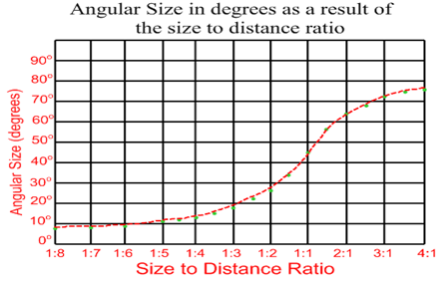

16. If an object has an angular size of 22º, what would its size to distance ratio be?

17. If an object has a size to distance ratio of 1:4.3 and it is 30 m tall, how far away is it?
18. If an object has an angular size of 15º and it is 15 m away, how tall is it?
19. If an object has an angular size of 18º and it is 19 m away, how tall is it?
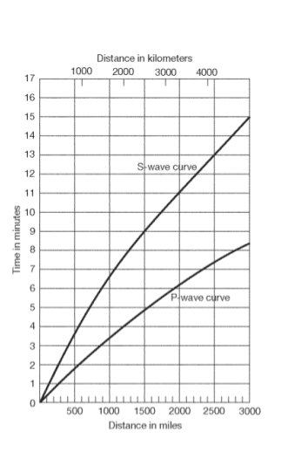

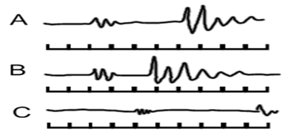

0 1 2 3 4 5 6 7 8 9 10 minutes

20. How far was each station above from the epicenter?
A = B= C=
21. At which station was there most likely the most damage and why?
22. How far does a P-wave travel in 10 minutes?
23. How long does it take an S-wave to travel 2000 km?

ELR ( Environmental Lapse Rate ) – (1ºC / 160m) or (.625ºC / 100m)
DAR ( Dry Adiabatic Rate ) - (1ºC / 100m)
MAR ( Moist Adiabatic Rate ) – (.6ºC / 100m)
DPD ( Dew Point Depression ) – (.2ºC / 100m)

24. What is the temperature at 2800 m, if it is 14º C at 350 m?

25. The temperature of a parcel of air is 12º C, what is it after rising 2450 m, if a cloud started forming at 1200m?

26. The temperature of a parcel of air is 32º C, what is it after rising 4550 m, if a cloud started forming at 2200m?

27. A parcel of air is at a temperature of 20º C at sea level and the surrounding air is at a temperature of 17 C, how high will the parcel of air rise?

28. A parcel of air is at a temperature of 24º C and the surrounding air is 13º C. If the dew point of the parcel of air is 16º C, will the parcel of air form clouds, if so, at what elevation?

29. The temperature of the air is 8oC. A parcel of air is heated to 14oC and its dew point is 9oC. At what level will clouds form if at all?

30. A parcel of air is at a temperature of 24º C and the dew point is 22º C, at what altitude will clouds form?

