NEWS
PLANETARY SCIENCE

Computer simulations heat up hunt for Planet Nine

Evidence accumulates for presence of orb on outskirts of solar system
BY
CHRISTOPHER CROCKETT
8:00AM, JANUARY 31, 2016
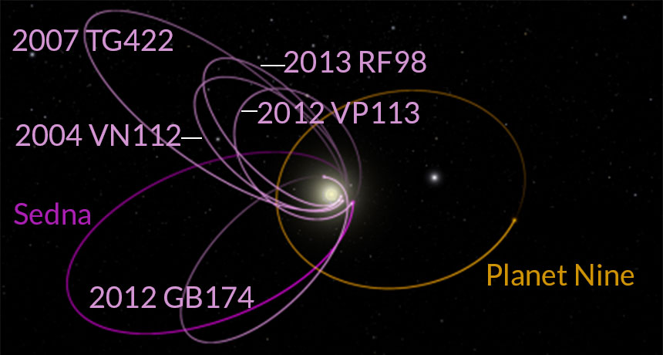
PLANETARY ALIGNMENT A giant planet (orange) could explain why the orbits of the six most distant objects from the sun (magenta) line up in a peculiar way.
CALTECH, R. HURT/IPAC, WORLDWIDE TELESCOPE
Magazine issue: Vol. 189, No. 4, February 20, 2016, p. 6
For a planet that hasn’t technically been discovered yet, Planet Nine is generating a lot of buzz. Astronomers have not actually found a new planet orbiting the sun, but some remote icy bodies are dropping tantalizing clues about a giant orb lurking in the fringes of the solar system.
Six hunks of ice in the debris field beyond Neptune travel on orbits that are aligned with one another, Caltech planetary scientists Konstantin Batygin and Mike Brown report (SN Online: 1/20/16). Gravitational tugs from the known planets should have twisted the orbits around by now. But computer simulations suggest the continuing alignment could be explained by the effects from a planet roughly 10 times as massive as Earth that comes no closer to the sun than about 30 billion kilometers — 200 times the distance between the sun and Earth. The results appear in the February Astronomical Journal.
Evidence for a stealth planet is scant, and finding such a world will be tough. Discovering hordes of other icy nuggets on overlapping orbits could make a stronger case for the planet and even help point to where it is on the sky. Until then, researchers are intrigued about a potential new member of the solar system but cautious about a still theoretical result.
“It’s exciting and very compelling work,” says Meg Schwamb, a planetary scientist at Academia Sinica in Taipei, Taiwan. But only six bodies lead the way to the putative planet. “Whether that’s enough is still a question.”
Hints of a hidden planet go back to 2014. Twelve bodies in the Kuiper belt, the ring of frozen fossils where Pluto lives, cross the midplane of the solar system at roughly the same time as their closest approach to the sun (SN: 11/29/14, p. 18). Some external force — such as a large planet — appears to hold them in place, reported planetary scientists Chad Trujillo, of the Gemini Observatory in Hilo, Hawaii, and Scott Sheppard, of the Carnegie Institution for Science in Washington, D.C.
This new analysis “takes the next step in trying to find this giant planet,” Sheppard says. “It makes it a much more real possibility.”
In addition to what Sheppard and Trujillo found, the long axes of six of these orbits point in roughly the same direction, Batygin and Brown report. Those orbits also lie in nearly the same plane. The probability that these alignments are just a chance occurrence is 0.007 percent.
“Imagine having pencils scattered around a desktop,” says Renu Malhotra, a planetary scientist at the University of Arizona in Tucson. “If all are pointing in the same quarter of a circle, that’s somewhat unusual.”
A hidden world might explain a couple of other oddities about the outer solar system. Dwarf planets Sedna and 2012 VP₁₁₃, for example, are far removed from the known worlds (SN: 5/3/14, p. 16). Planet Nine could have put them there.
The planet would also stir up some of the denizens of the Kuiper belt into orbits that are roughly perpendicular to the rest of the solar system — a population of five known objects that Batygin was surprised to learn exists. When he and Brown compared their simulations of an agitated Kuiper belt to these bodies’ cockeyed trajectories, they found a match.“If there was one dramatic moment in the past year and a half, this was it,” Batygin says. “We didn’t really believe our own story for the longest time. But here was the strongest line of evidence.”
Given what scientists know about how the solar system formed, the proposed planet is not native to its current environment. It probably originated closer to the sun and was kicked to the hinterlands after flirtations with the current roster of giant planets.
This wouldn’t be the first time scientists were led to a new world by the odd behavior of another. Astronomer Johann Galle found Neptune in 1846 after mathematicians Urbain Le Verrier and John Couch Adams calculated that an unknown planet could be causing Uranus to speed up and slow down along its orbit.
Uranus was a more clearly defined problem, says Scott Tremaine, an astrophysicist at the Institute for Advanced Study in Princeton, N.J. Le Verrier and Adams were trying to understand why Uranus appeared to defy the law of gravity, whereas Batygin and Brown are piecing together a story of how the solar system evolves.
“When we’re talking about history rather than laws, it’s always easier to go astray,” says Tremaine.
The orbital alignments are striking, he says, and Batygin and Brown have done sensible calculations. But he worries about hunting for statistical significance after noting a possible oddity. “That can be very misleading,” he says. “The numbers that won the Powerball lottery are an unusual combo, but that doesn’t mean anything.”
In the meantime, “the hunt for Planet Nine is on,” Batygin says. Data from NASA’s WISE satellite, which spent nearly nine months making an infrared map of the sky, rule out the existence of a planet as massive as Saturn out to 4.2 trillion kilometers from the sun, and a Jupiter-like world out to three times as far. If a smaller, cooler planet is out there, it’s probably in the outer third of its orbit, which puts it against a dense background of Milky Way stars, a planetary needle in a galactic haystack. “It’s not going to be impossible,” he says. “It just makes it harder.”
The Victor Blanco telescope in Chile and Subaru telescope in Hawaii are the best facilities for undertaking the search, Schwamb says. Both have cameras that can see large swaths of sky. If scientists don’t mind waiting, the Large Synoptic Survey Telescope will come online in 2023. Currently being built in Chile, LSST will image the entire sky once every three days.
“We would be able to detect Planet Nine even if it was moving slowly,” says Lynne Jones, an astronomer and LSST scientist at the University of Washington in Seattle. “We could look for motion from month to month or over the course of a year and quickly pick it out from the background stars.”
There’s also the possibility, though remote, that a serendipitous picture of the planet already exists. Uranus, Neptune and Pluto were all seen before anyone realized they were planets, dwarf or otherwise. Most observations don’t record things as faint as Planet Nine. “But there’s lots of archival data,” Sheppard says, accumulated in observatories as astronomers gather images of stars, nebulas and galaxies. “This could be sitting there somewhere.”
Questions? Write answers to the following questions on a sheet of paper. Either write the question or be sure to include question in answer.
- Have scientists found a new planet orbiting the Sun?
- Why do astronomers believe there could be another planet?
- How far out do scientists believe the new planet would be?
- Why are astronomers cautious about stating there is a new planet?
- Which planet was discovered as a result of the odd behavior of another planet?
- What was the odd behavior of the planet in the answer above?
- What evidence for a hidden planet was discovered in 2014?
- What is noticed about the long axis of the 6 farthest objects in the Solar System?
- What is the probability of the answer to number 7 happening accidently?
- What was discovered about some objects in the Kupier belt that is seen as the strongest evidence of a new planet?

