Names

**DATA:**

**Distance between X and Y = cm Distance between edge of table and centerline (z) = cm**

|  |  |  |  |  |  |  |  |  |  |
| --- | --- | --- | --- | --- | --- | --- | --- | --- | --- |
|  | Star 1 | Star 2 | Star 3 | Star 4 | Star 5 | Star 6 | Star 7 | Star 8 | Star 9 |
| Distance from location X (cm) |  |  |  |  |  |  |  |  |  |
| Parallax (cm) |  |  |  |  |  |  |  |  |  |

**Use the Data above to create a graph. Be sure to put correct variable on correct axis, label axis and put units, title graph, and draw line of best fit.**

1. Name the independent variable, dependent variable, and 1 constant.

2. Look at your graph and make a statement about how parallax and distance are related.

3. How does the parallax of a nearby object compare to that of a more distant object?

4. How much parallax would an **extremely** distant object have?

5. Could parallax be used to measure the distance to all stars?

Explain your answer.

**Leave the X and Y mark and the center mark on the table, but pull up your “stars”. Take your roll of paper, flip it over and reattach it to the table. Place another “star” along your center line at some unknown distance.**

7. Without using your meter stick to measure the “star’s” distance from X, how could you determine its distance? (explain)

8. Do what you said you could do in number 7 to determine the distance of your star and record **all** your data here.

9. What is the actual distance of your “star” from point X? If you were off by a large amount, please provide your explanation.

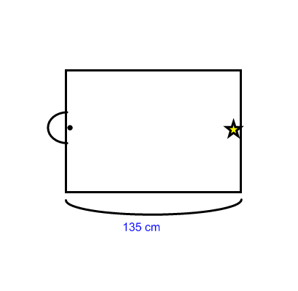10. Alpha Centauri is a star system located about 4.24 light years from Earth. A light year is the distance light travels in a year. The speed of light is 300,000 km / s. The average distance between the Earth and the Sun is 150,000,000 km.

How far should the Earth be from the

Sun on each side in the model to the side?

**R = 1 / θ** or **θ = 1 / R** R is distance in parsecs , θ is parallax angle in seconds

1. What is the parallax of a star that is 15 parsecs away?

2. Star A has a parallax of 0.12” and star B has a parallax of 0.03”, which star is closer?

3. What is the distance of a star with a parallax of 0.2”?

4. Star 1 is 14 parsecs away and star 2 is 36 parsecs away, which star has a greater parallax?

