Plate Tectonics Review NAME
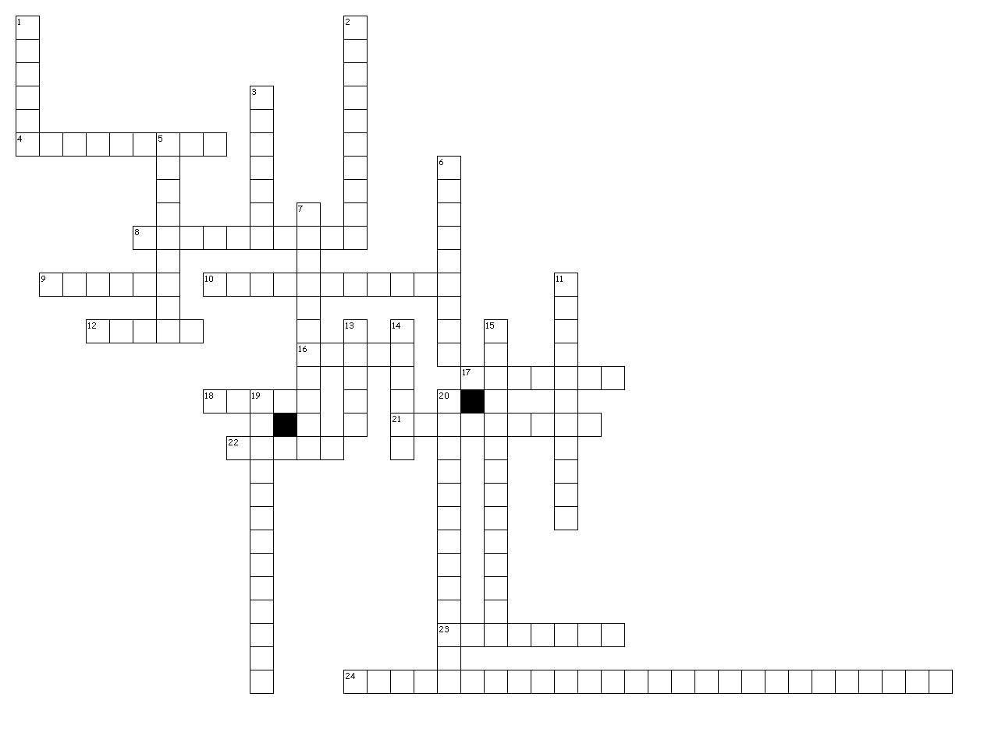

Across
4. Type of plate boundary where new oceanic crust is created.divergent
8. In plate tectonics, convection currents in the asthenosphere are what cause the plates to move which is something different from continental drift.
9. A huge wave that can be caused by an underwater earthquake. tsunami
10. Along with the fit of the continents, types of rocks, and climate data; They provide evidence of the continents once being connected.earthquakes
12. The number of seismic stations needed to locate an earthquake.three
16. Seismic wave that travels the fastest. P wave
17. The super-continent that existed about 200 million years ago.Pangaea
18. Seismic wave that can only travel through solids S wave
21. The surface location of an earthquake. epicenter
22. The best building material to withstand earthquake damage. steel
23. The difference in the arrival of P and S waves can be used to determine this about the epicenter of an earthquake. distance
24. earthquakes and volcanoes usually happen along plate boundaries

Down
1. The outer core is liquid metal which is why S-waves can not get through it.
2. Type of plate boundary where volcanoes and trenches are found subduction
3. Type of plate that always gets subducted because it is more dense oceanic
5. Composite cones have explosive eruptions because they have a lot of dissolved gases and viscous magma.
6. Along with the gases dissolved in magma, this is the most important factor in determining if an eruption will be explosive or not viscosity
7. The rigid outer layer of the Earth is called the lithosphere
11. Most destructive seismic wave. Surface wave
13. A crack in the ground along which movement has occurred. fault
14. Where in the ocean is the youngest crust found? center
15. Continental drift was not correct about how the continents moved and eventually turned into the theory of plate tectonics
19. The partially molten layer under the plates which allow them to move over it is called the asthenosphere
20. Volcanic mountain range at the center of the ocean. oceanic ridge

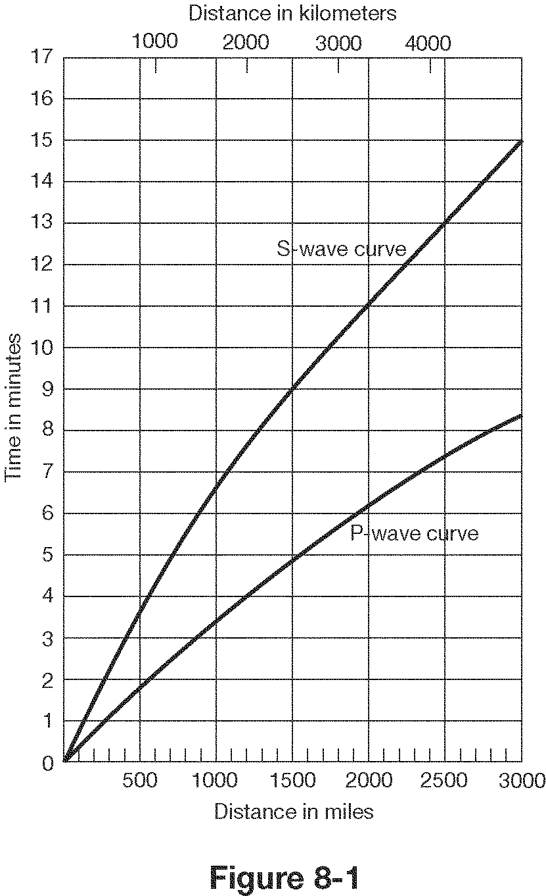

- How far does a P wave travel in 2 minutes? ____550 miles___
- How far does an S wave travel in 4 minutes?_______550 miles___
- How long does it take a P wave to travel 1500 miles?____5 min.______
- What is the lag time between P and S waves at 2000 km?____3.5 min.______
- What is the lag time for P and S waves at the epicenter?_______0____
- If there is a lag time of 4.5 minutes between P and S waves, how far is the epicenter?___1600 miles_______
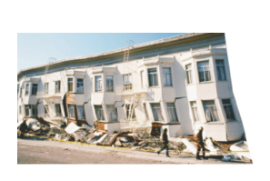
Match the following words with the correct definition and picture:

7. Seismogram - D a. sudden release of energy as deformed rock snaps
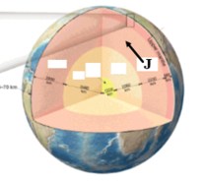

8.Lithosphere - E b. solid layer of Earth under the crust
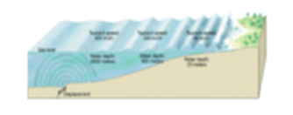

9. Epicenter - H c. huge wave caused by an underwater earthquake
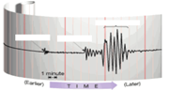

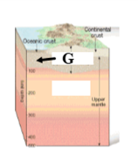
10. Mantle - B d. a recording of earthquake waves

11. Asthenosphere - I e. rigid layer of Earth made of crust and the uppermost mantle
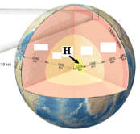

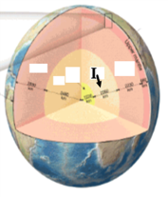
12. Fault - J f. solid innermost part of Earth, made of iron and nickel

13. Focus - K g. liquid layer of the Earth, made of iron and nickel

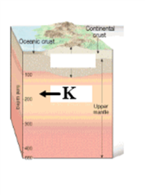
14. Outer core - G h. surface location of an earthquake

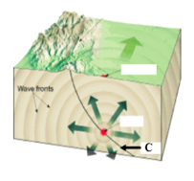
15. Seismograph - L i. semi-molten layer of Earth in the upper mantle

16. Tsunami - C j. crack in the Earth along which movement has occurred

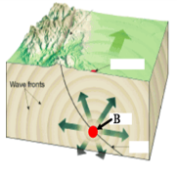
17. Inner core - F k. underground location of an earthquake, point of origin

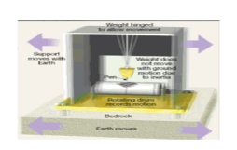
18. Earthquake - A l. devise that measures and records earthquake waves

