Plate Tectonics Review NAME
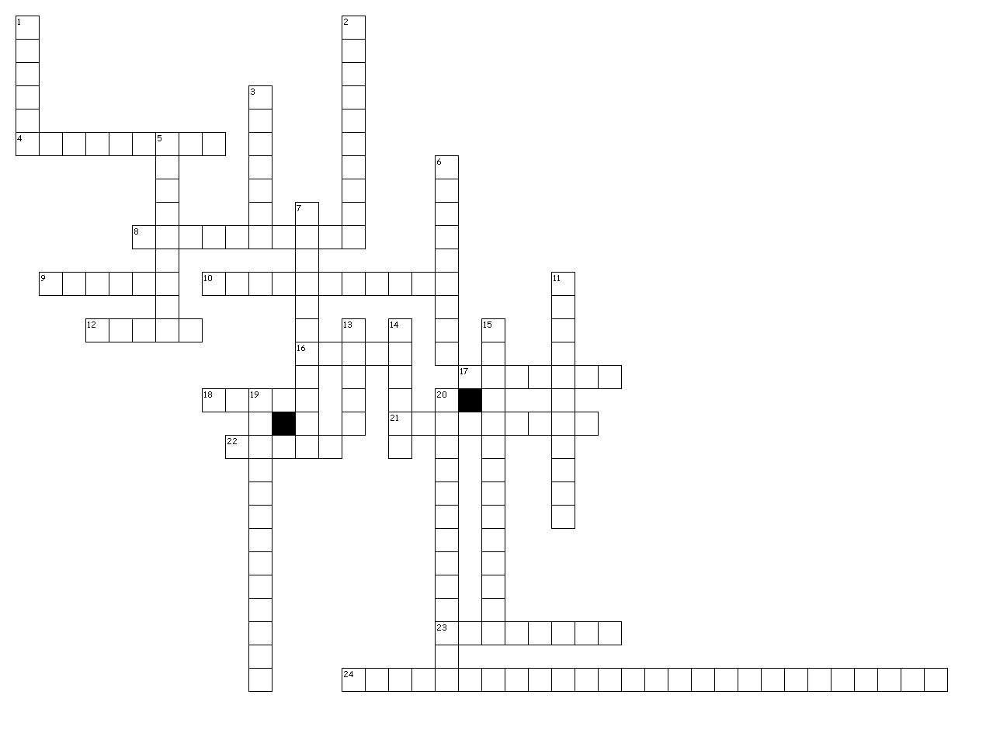

Across
4. Type of plate boundary where new oceanic crust is created.
8. In plate tectonics, currents in the asthenosphere are what cause the plates to move which is something different from continental drift.
9. A huge wave that can be caused by an underwater earthquake.
10. Along with the fit of the continents, types of rocks, and climate data; They provide evidence of the continents once being connected.
12. The number of seismic stations needed to locate an earthquake.
16. Seismic wave that travels the fastest.
17. The super-continent that existed about 200 million years ago.
18. Seismic wave that can only travel through solids
21. The surface location of an earthquake.
22. The best building material to withstand earthquake damage.
23. The difference in the arrival of P and S waves can be used to determine this about the epicenter of an earthquake.
24. and volcanoes usually happen along

Down
1. The outer core is metal which is why S-waves can not get through it.
2. Type of plate boundary where volcanoes and trenches are found
3. Type of plate that always gets subducted because it is more dense
5. Composite cones have eruptions because they have a lot of dissolved gases and viscous magma.
6. Along with the gases dissolved in magma, this is the most important factor in determining if an eruption will be explosive or not
7. The rigid outer layer of the Earth is called the
11. Most destructive seismic wave.
13. A crack in the ground along which movement has occurred.
14. Where in the ocean is the youngest crust found?
15. Continental drift was not correct about how the continents moved and eventually turned into the theory of
19. The partially molten layer under the plates which allow them to move over it is called the
20. Volcanic mountain range at the center of the ocean.

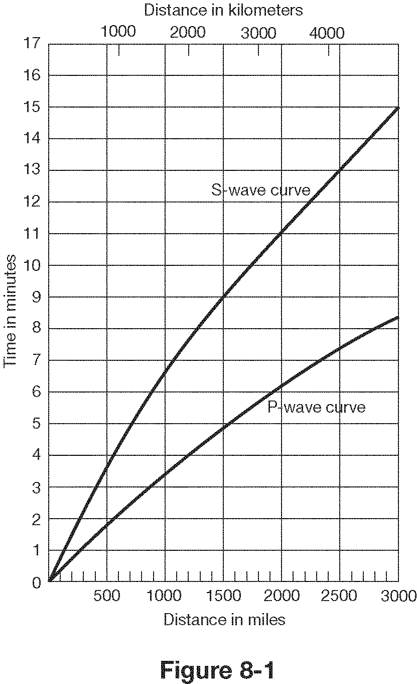

- How far does a P wave travel in 2 minutes? ________
- How far does an S wave travel in 4 minutes?__________
- How long does it take a P wave to travel 1500 miles?__________
- What is the lag time between P and S waves at 2000 km?__________
- What is the lag time for P and S waves at the epicenter?___________
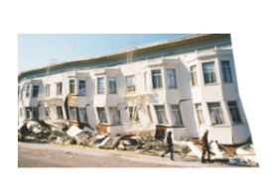
- If there is a lag time of 4.5 minutes between P and S waves, how far is the epicenter?__________
Match the following words with the correct definition and picture:

7. Seismogram - a. sudden release of energy as deformed rock snaps
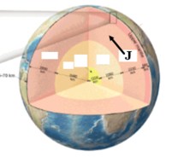

8.Lithosphere - b. solid layer of Earth under the crust
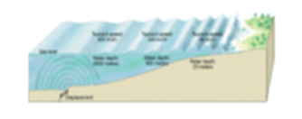

9. Epicenter - c. huge wave caused by an underwater earthquake
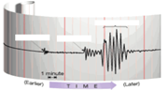

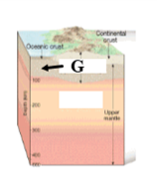
10. Mantle - d. a recording of earthquake waves

11. Asthenosphere - e. rigid layer of Earth made of crust and the uppermost mantle
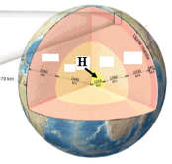

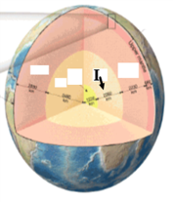
12. Fault - f. solid innermost part of Earth, made of iron and nickel

13. Focus - g. liquid layer of the Earth, made of iron and nickel

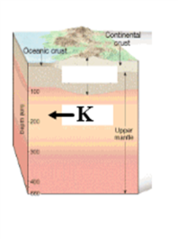
14. Outer core - h. surface location of an earthquake

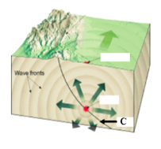
15. Seismograph - i. semi-molten layer of Earth in the upper mantle

16. Tsunami - j. crack in the Earth along which movement has occurred

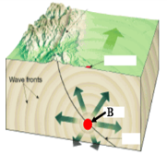
17. Inner core - k. underground location of an earthquake, point of origin

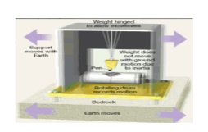
18. Earthquake - l. devise that measures and records earthquake waves

Know:
Types of plate boundaries and resulting landforms
Evidence of Plate Tectonics
Relationship between earthquakes, mountains, volcanoes and plate motions

