Name
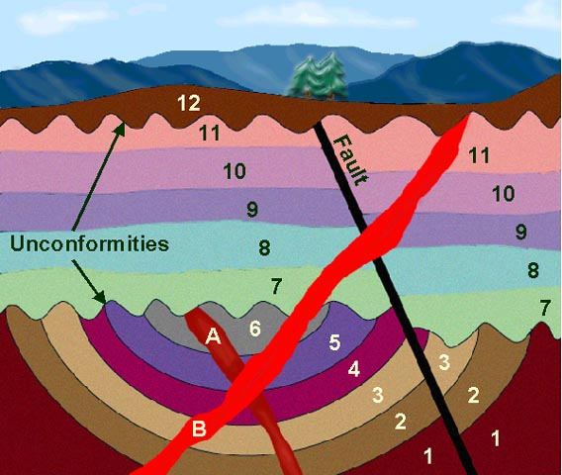

Which is older 10 or 11?
Which is older 2 or 3?
Which is older B or 11?
Which is older B or Fault?
What law tells us that A is younger than 6?
What law tells us that 7 is older than 8?
What law does 1 – 6 violate?
Place all of the above in the proper order using dating.

