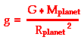
Solar System Questions Name

(G = 6.673×10⁻¹¹ N m²/kg²)

g for Earth is 9.8 m/s²

Calculate g for the planets below:

Planet Radius (m) Mass (kg) g (m/s²) Earth ratio Weight of 100lb object
Mercury 2.43 x 10⁶ 3.2 x 10²³
Venus 6.073 x 10⁶ 4.88 x10²⁴
Mars 3.38 x 10⁶ 6.42 x 10²³
Jupiter 6.98 x 10⁷ 1.901 x 10²⁷
Saturn 5.82 x 107 5.683 x 10²⁶
What are the two main factors that influence the surface gravity of a planet?

Velocity is distance divided by time. Given the information below, calculate the orbital speeds the following solar system objects:

Solar System Distance travelled Time (days) Time (hours) Velocity (mph)
Object in orbit

Mercury 223,700,000 miles 88 days

Jupiter 3,037,000,000 miles 4,331 days

Pluto 22,698,700,000 miles 90,582 days

Eris 39,714,720,000 miles 205,025 days
What happens to the velocity of a planet as its distance increases?
Why do you think this happens?

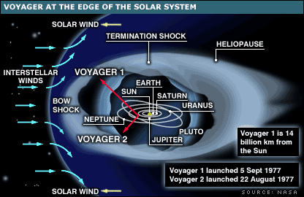
Voyager is a satellite that has been sent farther out into the Solar System than any other object. It has been travelling for 38 years and is currently 134.4 AU’s from the Sun. If it were travelling in a straight line from the Sun, how fast would it have to be travelling? (1 AU equals 93,000,000 miles and there are about 365 days in a year and 24 hours in a day)

SHOW YOUR WORK
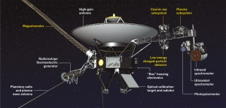

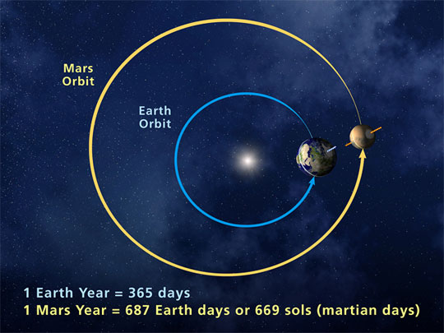
If we were to build a spacecraft that travels at 30,000 mph, how long will it take to send the spacecraft to Mars at its closest point to the Earth? (Earth is an average distance of 93,000,000 miles from the Sun and Mars is an average of 141,600,000 miles)
SHOW YOUR WORK

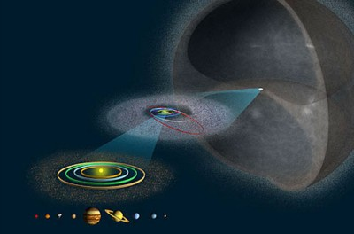
The Oort cloud, which is a sphere that surrounds our Solar System, goes out from 5000 to 100,000 AU’s. Assume voyager will travel outward at a speed of about 30,000 mph. About how long will it take voyager to get to the inner portion of the Oort cloud (assuming it doesn’t hit anything)?(1 AU equals 93,000,000 miles and there are about 365 days in a year and 24 hours in a day)
SHOW YOUR WORK

Did doing this activity change your view of our Solar System in anyway? What did you learn from doing this (if anything)?

