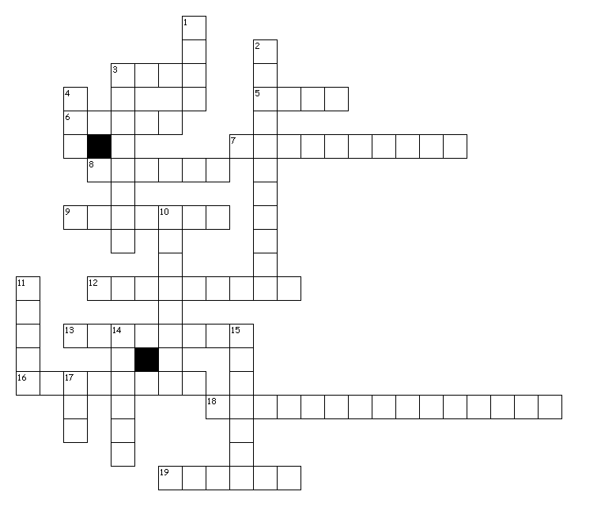
Astronomy Review 2016

Across

3. Supergiants are cool and bright .
5. Green light has more energy than yellow light.
6. Apparent magnitude is the brightness of a star as it appears from earth.
7. Brahe did NOT support this model of the solar system because he could not detect stellar parallax geoocentric
8. The Sun produces Energy through fusion .
9. The two forces keeping a planet in orbit are gravity and inertia
12. As the energy decreases, the wave length increases .
13. Parallax can be used to determine the distance of stars
16. The two gases that make up most of the sun are hydrogen and helium.
18. The absolute magnitude of a star is determined by:size and temperature
19. Radio waves are the longest waves and therefore have the lowest frequency.

Down

1. Phase of the Moon when we can get a lunar eclipse full
2. The color of a star is determined by its temperature.
3. Shape of a planets revolution around the Sun in the Copernican model (it was incorrect)circular
4. Phase of the Moon when the Moon is between the Earth and the Sun. new
10. As you increase the frequency, you increase the energy.
11. About how long it takes the Moon to go through its phases: month
14. Keplers second law states that planets must travel slower when they are at aphelion.
15. oval shape of planets orbits: ellipse
17. White dwarfs are hot and dim

20. Electromagnetic Spectrum - I a. outer layer of the solar atmosphere

21. emission spectrum – D b. surface of the Sun we see

22. Red Shift - H c. particles being emitted from the Sun

23. Sunspots - E d. type of spectrum that is only bright lines

24.Solar Flares - G e. dark areas of the Sun

25. Fusion - F f. way in which the sun produces energy

26. Photosphere - B g. huge eruption from the Sun

27. Corona - A h. change in light when stars are moving
away from Earth

28. Solar Wind - C i. all of the types of light

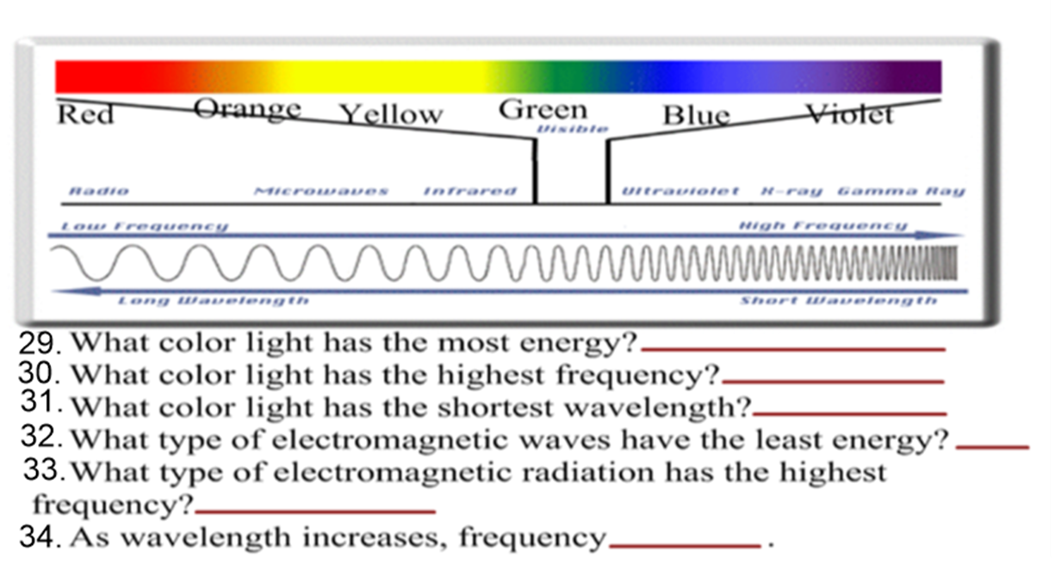

29. = VIOLET
30. = VIOLET
31. = VIOLET
32. RADIO
33. = Gamma
34. = decreases

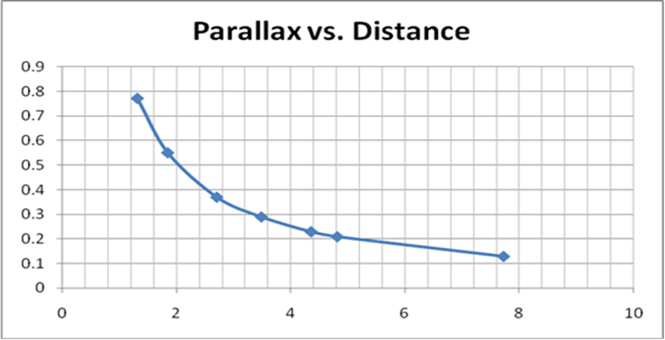

35. What is the parallax of a star that is 6 parsecs from Earth? 0.18”
36. What is the parallax of a star that is 3 parsecs from Earth? 0.32”
37. What is the distance of a star that has a parallax of 0.15”? 7 parsecs
38. What is the distance of a star that has a parallax of 0.7”? 1.5 parsecs
39. If the mass of an object doubles and the mass of another object stays the same, the gravity between them would double.
40. If two objects are moved twice as far apart as they were, what happens to the gravitational force between them? Four times weaker
41. What two things influence gravitational force? mass and distance
42. Which of the two listed above has a greater effect on the gravitational force? distance
43. Copernicus said the Sun was at the center of the Solar System, but was wrong when he said the planets travel in elliptical orbits.
44. Kepler corrected Copernicus when he said the planets travel in ellipticalorbits.

R = 1 / θ or θ = 1 / R R is distance in parsecs and θ is parallax in seconds
P² = a³ P is period in years and a is distance in AU’s
F = G (m₁m₂) / d² F is force, m₁ is mass 1, m₂ is mass 2, d is distance

45. What is the parallax of a star that is 4 parsecs away? ¼ = .25”
46. What is the period of a star that is 10 AU’s away? √(10³) =31.6 years
47. What is the distance of a star that has a parallax of 13”? 1/13 = .077 parsecs

48. An object has a mass of 45,000 kg and another object has a mass of 2,000,000 kg. If they are .4 km apart, what is the force of gravity between them? (45000)(2000000)/(.4)² = 5.625 x 10¹¹G

49. Star 1 has a parallax of 0.3” , Star 2 has a parallax of 0.009”, Star 3 has a parallax of 0.1” , and Star 4 has a parallax of 0.08”. Put these stars in order of closest to farthest. 1,3,4,2

50. What is the force of gravity between two objects that are 2 km apart and one has a mass of 200 kg and the other is 1000 kg? (200)(1000) / (2²) = 50,000G

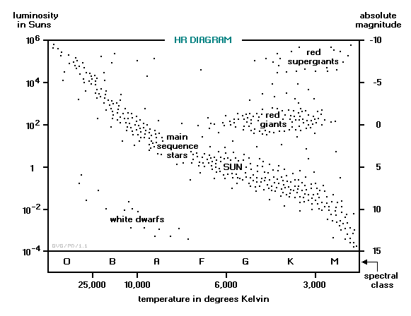

Use the data below and the
H-R Diagram to answer the
questions:
Star A Star B Star C Star D Star E

Ab. Mag. 15 -6 -5 12 6
Ap. Mag. 9 0 -6 15 6
Temp. 3400 31,000 3200 17,000 6300

51. Which star is a white dwarf? D 52. Which star is a supergiant? C
53. Which star is a small red dwarf star? A 54. Which star has the greatest luminosity? C
55. Which star appears brightest? C 56. Which star will have the longest lifespan? A
57. Which stars are burning hydrogen? A,B,E 58. Which star is burning helium? C
59. Which star is furthest along in its life cycle? D 60. Place the stars in order from closest to farthest:
A,C,E,D,B
61. Lunar Eclipse – G a. – spinning of a body on its axis

62. Solar Eclipse – F b. – orbit or motion of a body around a point in space

63. Heliocentric – D c. – average distance between the Earth and the Sun

64. Retrograde Motion – E d. - Sun centered model of the Solar System

65. Astronomical Unit – C e. – apparent backward motion of planets

66. Revolution – B f. – Moon casts a shadow on the Earth during a New Moon

67. Rotation - A h. – Earths farthest point from the Sun

68. Geocentric – J m. – Earths closest point to the Sun

69. Aphelion – H j. – Earth centered model of the Solar System

70. Perihelion - M g. – Earth casts a shadow on the Moon during a Full Moon

