Standard Semester Exam Study Guide 2016 Name
Skills Unit
Measurements
The four fundamental measurements most often used in science are:

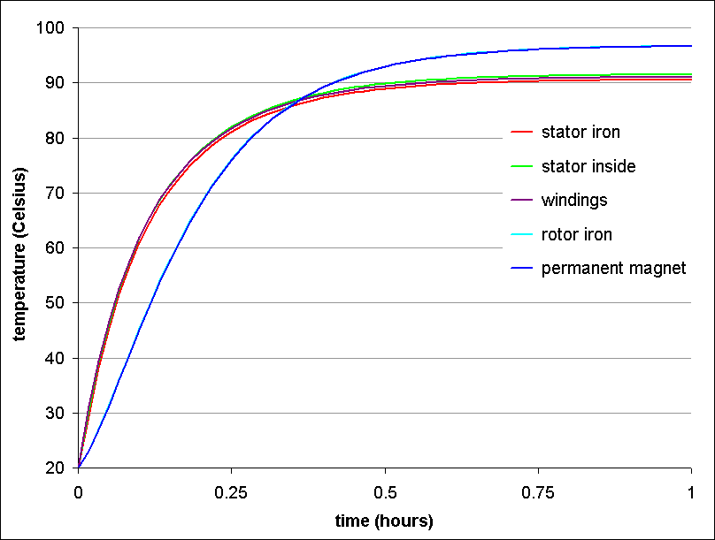

Scientific Literacy
What is the independent variable in the graph to the right?
What is the dependent variable in the graph to the right?
What is the title of the graph to the right?
At about what temperature are all items the same?
What is the highest temperature reached?
Variables
An experiment is done to see what toys make 3 year old boys the happiest.
What is the independent variable? What is the dependent variable?
What is a constant? The data was compared to a traditional teddy bear, the teddy bear is considered to be the of the experiment.
Scientific Notation
4.6 x 10⁻⁴ = 1.67 x 10⁸ = 0.0000987=
6.56 x 10⁸ = 0.000 045 = 218,000,000 =
Metric Conversions

48.76 mg = dg 0.02 km = m 11.3 kg = g
600,000 ml = hl 586.32 cm = mm 34,500 m = km

Chemistry
Parts of Atom
The three fundamental particles of the atom are the , , and .
and have mass, do not.
The atomic number is the number of in the nucleus.
Chemical / Physical Properties
Ice melting is a change. Ripping paper is a change. Cooking food like chicken is a
Change. Burning wood is a change.
Conservation Of Mass
The Law of Conservation of Mass states:
The balanced chemical formula 2 H₂ + O₂ → 2 H₂O shows how the Law of Conservation of Mass Works. Explain how?
Ions / Isotopes / Protons / Neutrons / Electrons
Element | Atomic # | Atomic Mass | # of Protons | # of Electrons | # of Neutrons | Charge
 |  |  |  | 0 | 0 | 1
 | 21 | 45 |  |  |  | Neutral
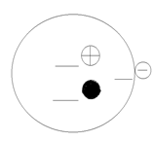
Atomic Number 9
Atomic Mass 19
Charge -1
Element ______
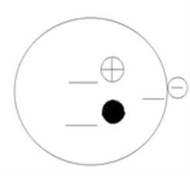
Atomic Number
Atomic Mass 14
Charge 0
Element N

Resources
Fossil Fuels / Renewable / Non-Renewable
Gas produced from the burning of fossil fuels which could be contributing to global warming.
Resources that take millions of years to replenish themselves are called resources.
The three fossil fuels are , , and
A rock that contains kerogen and is very plentiful in Colorado is
What is one benefit of natural gas over coal and oil?
Energy and Energy transformations
What types of energy are each of the following? An apple- A rolling ball -
A uranium atom - A compressed spring - A light bulb (on)-
Fracking
What is involved in the process of fracking?
Why do we frack?
What are the benefits of fracking?
What are the drawbacks of fracking?
Alternative Energy
Type of energy that comes from flowing water that is trapped behind a dam is called
A major problem with solar power is that it cannot be used at and is not .
Ethanol is a fuel that is produced mainly from .
The problem with wind and solar energy is that they are so you need a generator with them.
is the most plentiful fossil fuel in this country and is responsible for about 50% of our electrical generation.
Biggest problem with nuclear energy is which needs to be safely stored for many years.
Hydrogen could be a renewable resource because it can be obtained from .
Ethanol is a fuel that is produced mainly from .
Mining
Name 3 big expenses associated with mining:

Geologic Time
Relative Time
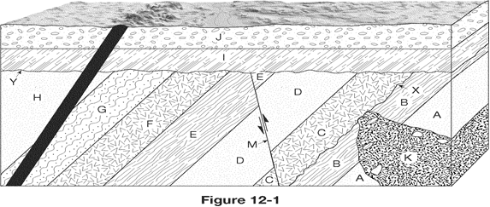
Is there anything in the figure that is younger than layer J? How do you know?
Put C,D,M and E in order of oldest to youngest.
Put A, K, C, and B in order from oldest to youngest.
Which is younger, fault M or layer D?
Which is older, layer I or layer E?
K→

What is the oldest layer in the figure? What is the youngest layer?

A(n) ____________________ is a surface that represents a break in the rock record, caused by erosion and represents missing information in geologic Time.
Fossils
The three criteria for an index fossil is:
Finding an index fossil in a rock layer gives what information about the rock layer?
What do we learn about Earth from fossils?
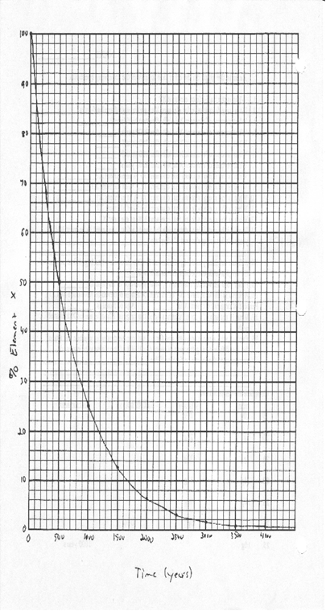
Absolute Time
What % of element x is around after 2700 years?
What % of element x is around after 1700 years?
What % of element x is around after 400 years?
What % of element x is around after 800 years?
A fossil is found to contain 10% of element x, how old is
the fossil?
A fossil is found to contain 84% of element x, how old is
the fossil?
A fossil is found to contain 6% of element x, how old is
the fossil?

